EQUELLA

EQ101 EQUELLA Core
Principles
Version 6.3
Table of Contents
Course Outline 3
EQUELLA repository 4
Session 1 5
EQUELLA digital repository 5
Dashboard page 5
Search, browse, save and share 8
Keyword and quick searches 9
Search page functionality 10
Save (or bookmark) the search results 11
Share search results 11
Cloud search 12
Collection and advanced searches 13
External repositories 14
Browse hierarchy 15
Resource summary and content 16
Comments 18
Add to favourites 18
Share with others 18
Structured and sequenced content 19
Favourites 21
Contribute resources 23
Collections and contribution forms 23
My resources 26
Edit a resource 27
Publish resources 28
Notifications 29
New versions 29
Thumbnails 30
Collaborate 30
Clone existing resources 31
Session 2 32
Content presentation 32
Find uses 36
Digital Rights Management (DRM) 39
User profile 41
Further exercises 42
EQUELLA Client support 47
International User Community 47

Course Outline

This course is a practical exercise in understanding the EQUELLA Digital Repository.
EQ101 is a prerequisite for the other EQUELLA courses. Participants must complete all exercises in the workbook.
There are also extension exercises that participants are encouraged to complete where time permits.
The course covers the following areas of the EQUELLA Digital Repository:
- EQUELLA technology and terms
- EQUELLA structure and searches
- EQUELLA resources and lifecycle
- Favourites
- Contributing resources
- My Resources
- EQUELLA content and rights
- Integrated EQUELLA
- User Profile and Scrapbook
- EQUELLA support, Professional Services, User Community, and Repository Showcases.

A few important points about EQUELLA
- EQUELLA is customizable and therefore each educational institute can set up EQUELLA to suit their business needs. Often this makes learning EQUELLA seem confusing and complex at first as it can be different to the supplied documentation.
- EQUELLA is privilege (permission) based and different access privileges are given to different users. Some users can only search, while others can add content or have control of the security (privileges). It is important that different users have different privileges, for example, a student should only have access to exam questions while a teacher can also access the answers.
  - In EQ101 users are assigned Educator/Researcher role privileges and have access to search, contribute and manage their resources.
  - Participants interested in extending their EQUELLA knowledge should join an EQ201 training course, where users are assigned Content Administrator role privileges and have access to administer other users’ resources.

EQUELLA repository

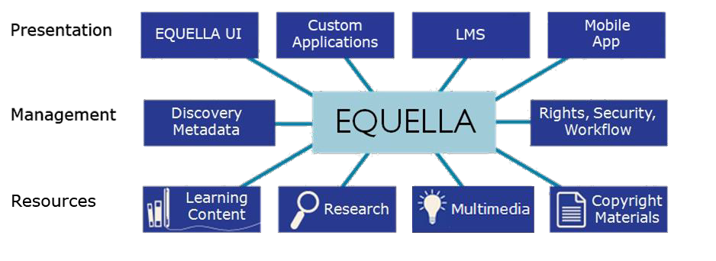
Architecture
EQUELLA’s architecture can include the following sections:
- Presentation—ways content stored within EQUELLA can be accessed include:
  - EQUELLA native UI—accessed using a browser and URL.
  - Integrated EQUELLA—accessed through a content presentation application or Learning Management System (LMS) such as Blackboard Learn™, Moodle™, Canvas, Learning Studio or Fronter.
  - Custom applications—accessed using EQUELLA’s SOAP or REST APIs.
  - Mobile app—accessed using an app tailored for iPads and Android tablets.
- Management and storage—EQUELLA enables tagging of content for easy search and discovery, and provides a range of other functionality such as DRM and workflow to ensure content is of good quality and is protected.
- Resources—EQUELLA can store and manage a range of content types including; simple descriptive text, Learning Objects (IMS, SCORM and METS packages), images, sounds, videos, PDFs, MS Office™, ZIP files, journal articles, book chapters, YouTube™ videos, Google Books™, iTunesU™ tracks, Flickr™ images, Kaltura™ media, Echo360 lectures, QTI, LTI, internal links to resources, files and webpages.

Anatomy
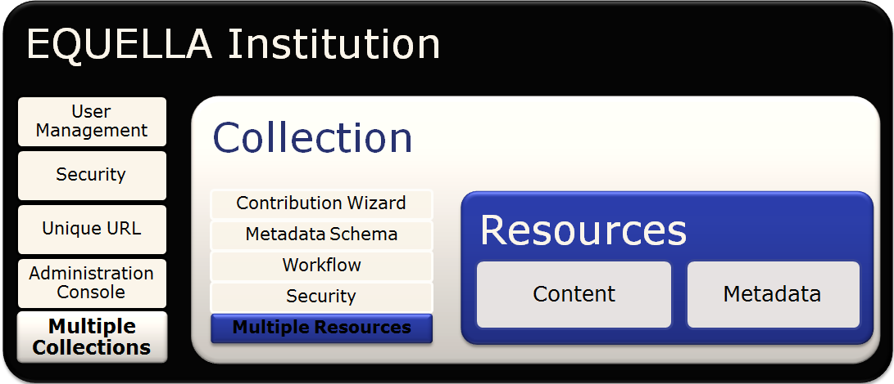
EQUELLA Institutions provide access to stored content for users, external applications and repositories. They provide infrastructure for managing users and digital content, and administration settings options for managing all aspects of EQUELLA.

Session 1

This session is to demonstrate and discuss:
- EQUELLA technology structure
- EQUELLA searches
- EQUELLA resources and lifecycle
- Favourites and sharing resources
- Contributing resources
- My resources
- Collaboration
- Notifications

EQUELLA digital repository
To login:
- Navigate to <url>
- Enter the username and password given to you by the trainer.
- Select Login then select OK for the Notice dialog to display the Dashboard page.

Dashboard page
The user’s Dashboard page is customizable and includes a navigation menu, portlets and context sensitive help. An example Dashboard page is shown in Figure 1 on page 7.

Navigation menu options
The navigation menu is displayed on the left-hand side of each page and contains options for accessing content that can include:
  - Standard group—Dashboard, Favourites, My resources, Search and Contribute
options.
  - Browse group—four hierarchy topics plus a More… option.
  - Custom group—options added, as required, by an administrator.
  - Administration group—Manage tasks, Manage external resources, Manage resources, Manage activations, Reports and Settings options.

Management options
Tasks, Notifications and your user profile are accessed at the top of the page.

Context sensitive help
Context sensitive help can be displayed by selecting the Help button.

<insert dashboard image>

Figure 1 Dashboard page

Portlets
Portlets are displayed in the central pane of the Dashboard page and typically display a summary of available content and links to access that content. The portlets can be added, edited, re-sized, re-ordered, removed and restored.
Screen options
Selecting the Screen options button on the Dashboard page displays a list of portlets that can be added including: Browse, Favourites, Formatted text, My resources, Quick search, RSS or Atom feed, Recent contributions, Scripted, Task statistics, Tasks and Web page.
Selecting the Screen Options button on the search pages displays a section where the results page display can be configured using the following options:
  - Include results that are not-live—check the box to include all resources in the results list.
  - Number of results per page—select an option from the drop-down list to vary the number of results displayed:
    - Minimum—10 results in Standard view; 30 results in Gallery view.
    - Medium—50 results in Standard view; 60 in Gallery view.
    - Maximum—100 results in Standard view; 90 in Gallery view (local only).
  - Search attachments—check the box to include attachment content in your search queries.

Breadcrumbs
Structural breadcrumbs can be displayed at the top of pages and provide a trail for the user to follow (e.g. Learning resources collection > EQUELLA Documentation).

Dashboard exercises
In these exercises you will learn about Help, Screen options and Portlets.

Help
- Select the button to display the help pane.
- Read the section on the Navigation menu.
- How would you find more information about this topic?

Screen options
- Note the portlets types that are on your Dashboard.
- Select the button to display the dashboard options pane.
- Note the other portlets types that can be added to your Dashboard.
- Add Browse and My resources portlets.
- Add a Recent contributions portlet (with default options).
- Minimise the Tasks portlet.
- Move the portlets around the Dashboard page.
- Move a portlet to the top to make the portlet full sized.
- Remove the My Favourites portlet.

Review the section then complete the extension exercises if time permits
Extension exercises
- Add Formatted text, RSS or Atom feed and Web page portlets.

Search, browse, save and share
EQUELLA provides a range of searching and browsing options for finding content including:
  - Local resource search—users can search for resources from all collections. The search results are displayed in the following views:
    - Standard—displays a results list with resource information, and users can select whether one, multiple or no attachment thumbnails are displayed.
    - Gallery—displays resources in a thumbnail format. Users can build a media gallery of image attachments in a grid style, and can select the thumbnail displayed.
  - Cloud search—provides access to resources stored in the cloud and occur simultaneously with the local keyword searches.
  - Collection searches—users can restrict their searches to within a selected collection.
  - Advanced searches—are customised searches used to find resources that match the selected search criteria.
  - Remote repositories searches—allows users to search multiple external sources including other EQUELLA repositories for content.
  - Browse hierarchy (topic) searches—users navigate through the sub-topics to find resources for specific topics.
EQUELLA users can:
  - Also search for content through their Favourites, My resources and Tasks options.
  - Share search results, and use resources by adding them as course content and to create other resources.
EQUELLA Administrators can configure:
  - Search relevance to be weighted by title, metadata or attachment.
  - EQUELLA collections so that resources can be included in common search engines, such as Google™ and Google Scholar search results.
Selecting Search from the navigation menu displays the Search page, an example is shown in Figure 2.

<insert image of Search page>

Figure 2 Search page

Further information on searching is provided in the EQUELLA Searching Users Guide and
EQUELLA Discoverability Guide.

Keyword and quick searches

Search methods
  - Keywords—the keywords entered display resources that have an exact match in their title, description, attachment name or applicable attachment content. Single and multiple keywords can be entered in the search text box:
- Entering multiple keywords with a space between each word displays results that contain all of the entered keywords.
- Entering multiple keywords with or displays results that contain any of the words.
- Search queries can contain optional Boolean logic to target keywords associated with resources.
  - Wildcard (*)—a wildcard character can be used to substitute for any character or characters in a string.
  - Autocomplete—means that users can type two or more letters and EQUELLA suggests words and resource titles based on the letters entered.
  - Stemming—EQUELLA recognises the root (stem) of a word entered and performs the search using the root term instead. For example, if ‘walked’ is entered the search
results for ‘walk´ (the stem word), ‘walking’ and ‘walks’ are also displayed.

Sort and filter options
Search results can be sorted and filtered to display more relevant results. Every results page in EQUELLA has sorting and filtering options that can change from page to page.

Search exercises
In these exercises you will learn about search results, sorting and filtering results.

Search and search results exercises
- Select the Search button from the navigation menu to display the Search page.
- Enter equella in the Search box then select the Search button or press enter.
- View the results list and note the total number of results
- Review the highlighted words for each result. Look at the relevance score and whether the key words were found in the title, metadata or attachment content. (Note: This EQUELLA has been set up to boost the Title x2.)
- Select the Gallery button to view the results as a gallery of images.
- Compare the results to the Standard page.
- Select the Standard button to return the results to standard view.

Sort exercises
- Select the Sort tab to display the Sort by options. Which option is the default?
- Sort the results by Title. Did the order of the results change?
- Reverse the order of the results.
- Sort the results by Date last modified. Did the order of the results change?
- Reverse the order of the results.

Filter exercises
- Select the Filter tab to display the filter by options.
- Filter the results list by owner (e.g. teacher) then select the Clear button.
- Filter the results list by PDFs then close the filter pane:
  - How many results are now displayed?
  - How do you know that filters have been applied?
- Select the Show attachments button for the yourEQUELLA features request
resource to display attachments and links to content.

Search page functionality
When a user returns to a previously visited local search page, the results list displayed is for the last search criteria and options selected. If filters are currently applied the Filter tab will be coloured orange. The default settings are displayed each time a user logs in.

Search results exercises
In this exercise you will learn about search page functionality and clearing filters.
- Select the Dashboard button to display the Dashboard page.
- Select the Search button to display the Search page.
- What do you notice about the results page?
- List 2 ways that you can clear the filters:

- Clear the filters and close the Filter pane, if applicable.

Review the section

Save (or bookmark) the search results
Search queries can be saved so they can be re-run at a future time without the need to re- enter the terms.

Save search results exercise
In this exercise you will learn about adding the search to a favourites list.
- Select the Add search to favourites button then save the search as EQUELLA Resources.

Share search results
Search results can be shared by sending the search results to other users. The sharing options include:
  - Share search results as an RSS or Atom feed—select the RSS feed or Atom feed link to display a subscription page. Subscribed users are notified when resources are updated or added to the search results.
  - Share search results via URL—copy and paste the URL into an email or other document. The EQUELLA log in page is displayed when the link is selected.
  - Share search results via e-mail—users can send results to others via email. Enter an email address then select the Send Email button. Check the Share only results viewable by guests checkbox if sending to users outside your institution.

Share search results exercises
In this exercise you will learn about sharing the search results list.
- Select the Share tab to display the Share search results options.
- List the sharing options
- Who will be able to access the search results when the URL is shared? _
- How many resources will be itemised in the results list that is shared?
- Close the Share pane.

Cloud search
The Cloud search occurs simultaneously with the standard EQUELLA search, and allows users to search and select content from the Open Educational Resources (OER) on the cloud.

Cloud search exercises
In this exercise you will learn about finding resources using a cloud search.
- Select the Found X cloud results button to display the Cloud search page.
- Review the results. Are they different?
- Select the search box then remove the search criteria then enter australia and press enter.
- View the results list and note the total number of results
- Filter the results list by education level (e.g. Higher Education) then remove the filter.
- Select the Local resources link to display the Search page. Are they different?
- Remove all search criteria.

Screen options exercises
In this exercise you will learn about changing the number of results displayed in the list.
- Select the Screen options tab to display the option pane.
- How many results per page are displayed by default
- Review the available options.
- Select the Cloud search and review the options.
- Change the option to Medium (50 results per page).

Review the section

Collection and advanced searches
Collection search
Collections are unique containers that group and store resources and associated information (metadata) within EQUELLA.

Collection search exercises
In this exercise you will learn about refining a search to a collection.
- Select the Within all resources drop-down list.
- Note the Collections listed.
- Select the Learning resources collection to display a list of resources in the collection.
- Enter doc in the Search box then select equella documentation and then press enter.
- Select the Add search to favourites button then save the search as Useful EQUELLA documents.
- Remove all the search terms and filters.

Advanced search
An advanced search enables searching specifically within the information (metadata) associated with resources.

Advanced search exercises
In this exercise you will learn how to search using specific information.
- Select the Within all resources drop-down list then Learning resources search from the Advanced searches group.
- Select colour images using the Format of resource and Image type options.
- Enter tas in the Search box then select tasmania and then the Search button.
- Save the search as Images of Tasmania.
- Select the Edit query button to include exam as the Learning resource type.
- Why were no local results found? _
- Select the Clear button to remove the advanced search criteria.
- Which search criteria were not removed?
- Remove the search terms and change the drop-down list to Within all resources.

Review the section

External repositories
EQUELLA currently supports the following remote repository search types:
  - Z39.50—libraries and major databases.
  - SRW—internet pages.
  - SRU—Search/retrieval via URL.
  - MERLOT—higher education learning materials.
  - EQUELLA—other EQUELLA repositories.
Search results can be imported into a configured collection contribution form. Remote repository searches can be accessed from the:
  - Search page—Within all resources drop-down list; or
  - Contribute page under the collection where the result information can be imported.

External repository search exercises
- Select the Libraries Australia repository from Within all resources—Remote repositories options.
  - Search for tasmania and view the results list.
  - Search for other topics.

Review the section
Notes

Browse hierarchy
Each topic (level) in the browse hierarchy can display key resources, resources and further topics. Users ‘drill-down’ by selecting a sub-topic or move up by selecting a breadcrumb link. Each topic can display the total number of resources displayed in its sub-topics.
Key resources are important resources for that topic and are displayed at the top of the results list.

Browse topics exercises
- List 2 ways that you can access the browse hierarchy:

- Browse to find the Websites folder (topic). How many resources contain a website?
- Filter by community keyword.
- Save the search as User community.

Clear filters.
- Navigate to the Browse page using the breadcrumb navigation at the top of the page.
- Browse the topics to find a Key Resource. What colour is used to highlight key resources?
- What type of resources are key resources?

Review the section then complete the extension exercises if time permits
Extension exercises
- Search for a video using 3 different search types. Which search types did you use?

- Search an external repository for nursing content.
- Where would you find a key resource?
- How would you set up an RSS feed for search results? This exercise is intended to improve your familiarity with your EQUELLA.
- Login to your EQUELLA (If you cannot do this then complete the Further exercises).
- Repeat the exercises from the Search, browse, bookmark and share section, using applicable keywords.

Further exercises (using the training institution)
- Refer to the Further exercises section on page 42.

Resource summary and content
Selecting a resource title from the search results list displays the Resource page (Figure 3).
<insert image of Resource summary page>

Figure 3 Resource page

The Resource page provides a summary of the resource and can comprise title, description
and other descriptive data entered during contribution, plus the following:
  - Links to resources section—displays content, information and viewer options.
  - <x> comment section—displays previously added text and ratings.
  - Add a comment section—allows text and ratings to be added.
  - Prev/Next buttons—navigate to the previous or next resource in the results list.
  - Add to favourites button—allows the resource to be saved in Favourites list.
  - Share with others button—provides a resource link that can be emailed to colleagues, allowing them to view the resource for a specified time.
  - Details pane—displays information about the resource and can include: Owner, Collaborators, Collection, Version, Status, Find uses, Moderation history, Terms of use, Moderation Progress and Activations options.
  - Actions pane—displays operations that can be used for the resource and can include: Add to external system, Archive this version, Change ownership, Clone item into a collection, Create a new version, Delete this version, Edit this version, Export, Make this version live again, Mark this for review, Modify key resource, Move item into another collection, New contribution of same type, Purge from EQUELLA, Redraft this version, Restore this version, Resume this version and Suspend this version actions.
Content can be managed in EQUELLA or externally, and include:
  - uploaded—Word, Excel, PDF, ZIP, IMS, SCORM, METS, QTI, movies, audio, images
  - linked—URLs, YouTube, GoogleBooks, Flickr, iTunesU, Kaltura, LTI Further information is provided in the EQUELLA My Resources User Guide.

Resource summary and content exercises
In these exercises you will learn about resource summary details, actions, and content types.
- Enter equella in the Quick search portlet then select equella user community and then the search button to display the search results.
- Why is the EQUELLA User Community resource not at the top of the results list?
- Change the Sort results by drop-down list to Relevance and review the results.
- Select the Show attachments button to display attachments and links to content.
- Select EQUELLA User Community resource title to display the resource summary page.

Details pane and information
  - Who is the Owner of this resource?
  - Which Collection is it in?
  - Note the resource’s Version number _ Status

Actions pane
- Review the operations that are available for an Educator/Researcher role user:
- Why shouldn’t a user with an Educator/Researcher role have permissions to edit or delete this resource?

Information and links to resources
- Note the other information (metadata) provided on the summary page.

- Select the Show details drop-down arrow to display information about the content.
  - Is the content uploaded or external (linked) content?
- Select the EQUELLA User Community website link. It is useful to join the EQUELLA International User Community. If you are interested then please send an email.

Next/Previous
The buttons allow a user to move through the resource summary pages without having to return to the results page.

Next/Previous exercises
In this exercise you will learn about navigating through search results.
- Select the Next button. What is displayed? _
- Select the Next button then the Prev button.
- Select the Search button from the navigation menu. Compare the search results to the resources you have been scrolling through.

Review the section

Comments
Users can add comments and rate resources. When resources have been given a rating then users can Sort results by User rating to find quality resources.

Comment exercises
In this exercise you will learn about adding comments and ratings.
- Add a comment to the resource.
- Add a rating to the resource.
- View all comments added to the resource.
- Find other resources that have a user rating. Which Sort option did you use?

Add to favourites
Individual resources that are frequently used can be added to the Favourites|Resources list to enable quick access. The added tags can be used in a keyword search to discover the resource.

Favourites exercises
In this exercise you will learn about adding a resource to a favourites list.
- Navigate to the equella user community resource summary.
- Select the Add to favourites button then add tags (e.g. join, worldwide).
  - If the Always use latest version option is selected, will the resource saved in
Favourites be updated when a new version of this resource is added?

- Select the Add button to add the resource to your Favourites | Resources list.

Share with others
Users can share the resource with an outside source by sending an email containing a link that is accessible for a set period of time.

Share exercises
In this exercise you will learn about sharing the resource.
- Select the Share with others button to display the Share with others dialog.
  - What is the shared users access restricted by?_
- Use the breadcrumb to return to the EQUELLA User Community resource.

Review the section

Structured and sequenced content
EQUELLA resources can be packaged by adding a navigation structure. Combining the resource content allows teachers to group activities into a sequence of tasks.

Sequence exercises
In these exercises you will learn about organised content.
- Navigate to the EQUELLA documentation resource summary page:
  - Review the information (metadata) provided on the summary page.
  - Select the EQUELLA Support link and review how the content is displayed.
  - Is this content stored and managed in EQUELLA or externally?
  - Select the Glossary link and review how the content is displayed.
  - Is this content stored and managed in EQUELLA or externally?
  - Select the Full Screen link and compare how the content is displayed.
  - Select the resource’s title link (e.g. EQUELLA Documentation) to return to the resource summary page.
  - Select the Full screen (new window) link then compare the content display.
  - Return to the resource summary page.
  - Save the resource to your Favourites list.
- Find the Overland Track resource and review the information (metadata) provided on the summary page.
  - List an external (or linked) content type:
  - List an uploaded content type:
  - Select the Full Screen link then Full screen (new window) and compare how the content is displayed.
  - Return to the resource summary page then Add to Favourites.

Thumbnail view exercises
- Search for the EQUELLA Institutions resource. Review how the resource content is displayed on the search page and the resource summary page.
  - Why are these different to other resources?
  - Which collection is this resource stored in?

Review the section then complete the extension exercises if time permits

Extension exercises
- On which page is the date when the resource was last modified displayed?
- On which page are resource comments and ratings displayed?
- How would you share search results with other users? _
- Sharing a resource via email is intended for regular or casual EQUELLA users?
- Find and familiarise yourself with the EQUELLA Searching User Guide and My Resources User Guides.
This exercise is intended to improve your familiarity with your EQUELLA.
- Login to your EQUELLA (If you cannot do this then complete the Further exercises).
  - Find a resource and repeat the exercises from the Resource summary section.

Further exercises (using the training institution)
- Refer to (or continue with) the Further exercises section on page 42.

Favourites
Users can save (or bookmark) resources and searches they find useful by using EQUELLA’s Favourites functionality.
The Favourites page is displayed by selecting the:
  - Favourites button from the navigation menu; or
  - Show all button from the Favourites portlet.
The Favourites page contains Resources and Searches categories, an shown in Figure 4.
<insert image of the Favourites page>

Figure 4 Favourites page

Further information is provided in the EQUELLA My Resources User Guide.

Favourites exercises
In these exercises you will learn about bookmarked searches and resources.
- Add a Favourites portlet to the Dashboard page and review the list.
- What other option can you use to access the Favourites page?
- Access the Favourites page via the Show all button in the portlet or the Favourites
button in the navigation menu.
- The Favourites page contains which 2 categories?
- Is the currently displayed category shown in black or blue?

Resources category
- Select the Resources option.
- What type of results are listed in the Resources category?

- What type of information is displayed for each resource?

- What option has been added to the Sort results by list?
- Search for a resource using the tags you entered.
- View the resource summary.
- Navigate back to the Favourites page.
- Which category is currently displayed? _

Searches category
- Select the Searches option.
- What type of results are listed in the Searches category?
- What type of information can be displayed for each result?

- Select a link to view the results list (e.g. EQUELLA resources).
- How many resources are displayed?
- Navigate back to the Favourites page.
- Which category is currently displayed?

Remove Favourites
- Remove the Overland Track resource from your Favourites | Resources.
- Remove the Images of Tasmania search from your Favourites | Searches.

Review the section then complete the extension exercises if time permits

Extension exercises
This exercise is intended to improve your familiarity with your EQUELLA.
- Login to your EQUELLA (If you cannot do this then complete the Further exercises).
  - Repeat the exercises from the Favourites section using applicable information.

Further exercises (using the training institution)
1. Refer to (or continue with) the Further exercises section on page 42.

Contribute resources

Collections and contribution forms
EQUELLA Collections are used to group and store resources. Each Collection has a different Contribution form that is customised to suit the type of content they store.
Selecting the Contribute button displays the Contribute page with a list of Categories and
Collections. A list of Contributions in progress can also be displayed.
Selecting a Collection (e.g. Learning resources collection) displays a contribution form, an example is shown in Figure 5.
<insert contribution form>

Figure 5 Contribution Form

Some Contribution forms are dynamic and only display controls or pages when a particular option is selected. This helps to collect meaningful information during the contribution process because only relevant fields are displayed.
The example contribution form shown in Figure 5, contains text boxes (Title, Description), a group of check boxes to select multiple options (Media) and the ability to add attachments and link content (Add media to your resource).
Mandatory fields are denoted by an *. These fields must be filled out before the resource can be published to the repository or submitted for moderation. If all mandatory fields are not completed the resource can only be saved as a Draft resource.
Each Contribution form can contain multiple pages and the page names (e.g. About, DRM) are displayed on the right-hand side of the page.
Further information is provided in the EQUELLA Contribution User Guide.

Contribute a resource exercises
In these exercises you will learn about adding resources to the repository.
The exercises suggest that you add <yourname> in the title. This is only necessary for training and helps you to easily identify your resources while you familiarise yourself with EQUELLA.

To display the contribution form
- Select the Contribute button from the menu to display the Contribute page.
- Select the Learning resources collection in the Training Collections category to display the Contribution form.
- How many pages does this form have?
- What information (metadata) is mandatory?
- If you leave out the mandatory information what effect does this have?_
- Enter EQ101 new resource <yourname> in the Title field.
- Enter This is an exercise for contributing a resource in the Description field.
- Select the Media checkbox from the Media section.
  - What happens?
- Is this a dynamic or static contribution form?

To add content
- Select the Add a resource link.
- Review the content type options. How many are there?
- Select the Upload a file option then the Next button.
- Browse to find and select a Word document and image file then select the Add button.
- Add a URL (e.g. http://www.equella.com) then change the Display name (e.g.
EQUELLA website) and then select the Save button.
- Add a YouTube video (e.g. EQUELLA with love).
  - Can you select more than one result?
- Select the Edit link then change the display name for the image.

To add extra information (metadata)
- Select the Classification metadata checkbox from the Media section.
  - How does the Contribution form change?
- Select the Classification button to display the next page.
- How would you know if this is the last page that needs to be completed? _
- Enter Keywords.
- Select the Select terms link to display the Learning Resource Type dialog.
  - Browse or Search for terms then select the View link.
  - Select the applicable terms then select the OK button.

- Select the Formats of files stored in this resource (e.g. document, video, website etc).
- Preview the resource.
  - Select the Reorder attachments link and move the image to be the first attachment. (Note: drag-n-drop the attachment or use the up and down arrows.)
  - Save the reordering then close the preview.
- Select the Save button then the Save draft button to add a draft resource to EQUELLA.

Notifications
Contributors can notify other users that a resource is publically available.

Add users to notify exercise
- Select the Share with others button to display the Share with others page.
- Select the Select more users to notify link to display the Select users dialog.
- Enter search terms (e.g. user) then select the Search button.
- Check the boxes for all users in the training group (and include yourself).
- Select the Select these users button to display a list of users in the Users pane.

Review the section then complete the extension exercises if time permits
Extension exercises
- Does the newly contributed resource appear in the results of a saved Favourite search?
  - If not why not?
- Access the Books - Libraries Australia repository from the Contribute page.
  - Import a search result then review the imported information.
  - Add any required information then Save the resource to EQUELLA.
  - View the information displayed. Which collection was the resource added?
- Access the Journals - Libraries Australia repository from the Contribute page. Repeat the Books - Libraries Australia exercises.
- Look at other collections, select options and use different types of controls.
- What is the advantage of dynamic contribution forms?
- Add two extra Recent contribution portlets to the Dashboard page with different
Status and Query information.
  - Compare the results for the Recent contribution portlets.
- Find and familiarise yourself with the EQUELLA Contribution User Guide.

Further exercises (using the training institution)
- Refer to (or continue with) the Further exercises section on page 42.

My resources
The My resources page displays resources that belong to the currently logged in user. A category bar at the top of the page provides the following options:
  - Published—displays all published resources.
  - Drafts—displays unpublished resources.
  - Scrapbook—displays personal resources.
  - Moderation queue—displays resources in moderation workflow process.
  - Archive—displays the previous versions of resources that have been archived.
  - All resources—displays all content including resources and personal resources.
  - Purchased—displays purchased resources.
The current category selection is shown in black and the others in blue, an example is shown in Figure 6.
<insert My resources page image>

Figure 6 My resources page

Further information is provided in the EQUELLA My Resources User Guide.
Notes

My Resources exercises
In this exercise you will learn about finding your resources.
- Find your Draft resource using a navigation menu button.
  - Which menu button did you select?
  - Which My resources category link did you select?
- Note which thumbnails are displayed in the search results list?
- View the resource summary page.
- From the Details section note the:

Owner:
  - Collection:
  - Version:
  - Status:
- Review the Actions that are available for an Educator/Researcher role user for their
Draft resources.
- Why should a user with an Educator/Researcher role have permissions to edit or delete this resource?

- Select the Reorder attachments button and move the Word document to be the first attachment.
  - Will this change which thumbnail is displayed in the search results?

Edit a resource

Edit the resource exercise
In this exercise you will learn how to edit your resources.
- Select the Edit this version option from the Actions pane to display the contribute form.
- Select the Edit link for the attached Word™ document to display the Upload files from your computer dialog. An example is shown in Figure 7.

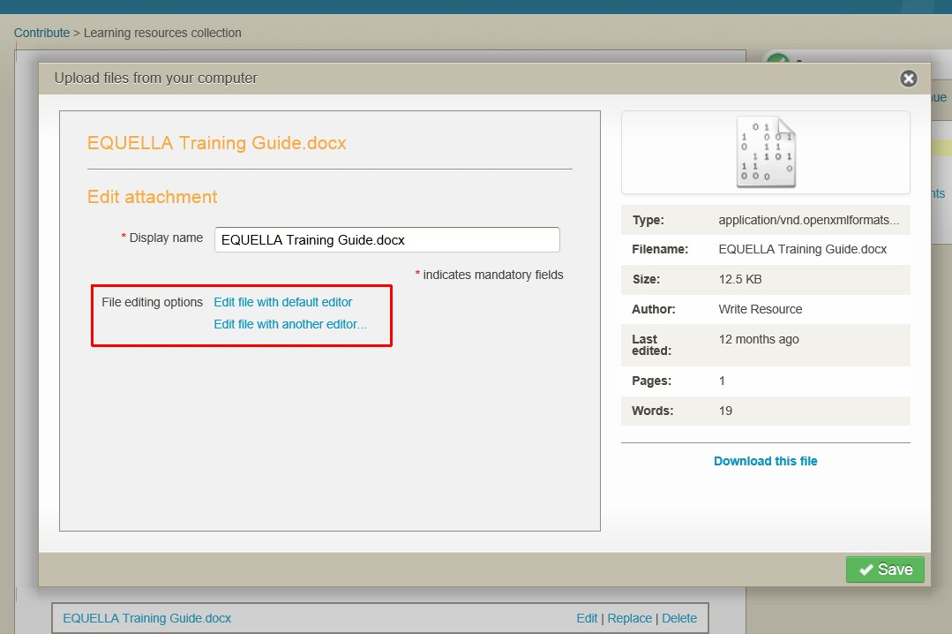

Figure 7 File editing options

- Select the Edit file with default editor link to display the document in Word™.
- Change the document then Save and Close the document.
- Select the Upload changes button to add the edited document to the resource then select the Save button.

Publish resources
- Select the Save button and Publish it to the repository.
- What did the Status change to?
- Why didn’t the Version number change?
- Review the Actions that are available for an Educator/Researcher role user for their
Live resources.
- Why shouldn’t a user with an Educator/Researcher role have permissions to edit or delete their Live resource?

- Why should you be able to create a new version of this resource? _
- Add a comment and rate the resource.
- Add to Favourites using the This version option.
- Which navigation menu options can you use to find your Live resource?

- Which portlets help you find your Live resources?

Notifications
The user is alerted to notifications in the All notifications section of the Tasks portlet, and a bell icon with the number of notifications at the top of the page.

Notification exercises
In this exercise you will learn how to check and clear your notifications.
- Select the Notifications icon to display the Notifications page.
  - Review the Reason listed and the Filters that are applied.
- Select the Dashboard button to display the Dashboard page.
- Select Resources which the owner notified you of going LIVE from the All notifications section of the Tasks portlet to display the Notifications page.
  - Review the Reason listed and the Filters that are applied.
- Clear the notification.

New versions

Create a new version exercise
In this exercise you will learn how to create a new version of the resource.
- Create a new version of the resource and change the content.
- Save and Publish the resource to the EQUELLA Digital Repository.
- Note any changes in the Details section:
- View the Moderation history.
- Why isn’t the comment displayed?
- Which version of the resource is displayed in Favourites?

Review the section

Thumbnails
The following image thumbnail options can be selected:
  - Default thumbnail—displays the first thumbnail listed in the resource on the Gallery page. And displays a rotating thumbnail on the Standard results page when there are multiple thumbnails listed.
  - No thumbnail—no thumbnail is displayed on the Gallery page or on the Standard
results page.
  - Select thumbnail—allows the user to select the thumbnail that is displayed on the
Gallery and Standard results pages. (The image thumbnails will not rotate).

Thumbnail display and reordering exercise
In this exercise you will learn the different image display options.
- Find your Live resource. Note how it is displayed in the Standard view
- Note how it is displayed in the Gallery view search results
- Select the title then select Edit this version action to display the contribution form.
- Select the Select thumbnail link. Which thumbnail will be displayed for each option:

Default thumbnail
  - No thumbnail
  - Select thumbnail
- Choose the video using the Select thumbnail option then the Save button.
- Save the resource. Why aren’t there options to Save draft or Publish?
- Note any changes in the Standard view search results:
- Note any changes in the Gallery view search results: _

Collaborate
When a contributor shares the ownership of a resource, they grant the selected users the same permissions as they have.

Collaborate exercises
In this exercise you will learn how to add collaborators to a resource.
- Find your Live resource.
- Select Change ownership from the Actions pane then select Add collaborators link.
- Use a letter (e.g. u), partial name or name (e.g. user1) to search for a class participant.
- Check the box then select the Select these users button.
- What actions will the collaborator now have for this resource that they didn’t have before you shared ownership?
- What other option is available in the Owner and collaborators page?

Clone existing resources
The Clone item into a collection operation allows a resource to be duplicated without saving the history of the original resource. The cloned resource can be added to the same or a different collection, with or without attachments and the original version remains live.

Clone a resource exercise
In this exercise you will learn how to clone a resource.
- Search for EQUELLA Documentation resource.
- Note the Version number
- Review the Moderation history.
- Select the Clone item into a collection operation from the Actions pane.
- Select Learning resources collection from the Select a collection drop-down list.
- Select the Clone button to display the contribution form.
- Add <yourname> to the beginning of the Title field (e.g. Sandra’s Documentation).
- Select the Save button then Publish to add a cloned resource.
- Why did the version number change? _

Review the section then complete the extension exercises if time permits
Extension exercises
- Add Kaltura, Google Book, Flickr and LTI attachments to your resource.
- Find and familiarise yourself with the EQUELLA Contribution User Guide.
- Refer to (or continue with) the Further exercises section on page 42.

Session 2

This session is to demonstrate and discuss:
  - Learning Management Systems (LMS):
    - Adding resources from EQUELLA to LMS
    - Adding EQUELLA resources through a LMS
  - Digital Rights Management (DRM)
  - User Profile
  - Scrapbook (personal resources), Repository Showcases and selecting existing EQUELLA resources.
  - EQUELLA Support, Professional Services, User Community and Training Courses.

Content presentation
EQUELLA can be integrated with content presentation software aka Learning Management Systems (LMS). EQUELLA can integrate with:
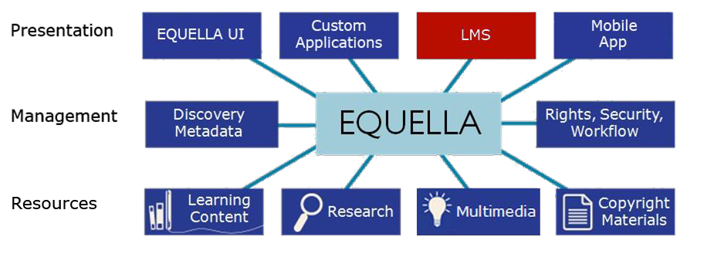
  - Pearson LearningStudio, Fronter, Moodle™, Blackboard Learn™, Sakai™, Canvas and Angel.
Users can create and add resources to courses or contribute resources to EQUELLA from within the LMS.
In Moodle, Blackboard Learn and Canvas LMSs, resources stored in EQUELLA can be linked to in two ways:
  - From EQUELLA using the Add to external system action (aka push to LMS).
  - From the LMS using the add EQUELLA resources or object options.
Further information is provided in the EQUELLA Push to LMS Guide, EQUELLA Moodle User Guide, EQUELLA Blackboard Learn User Guide and EQUELLA Canvas User Guide.

EQUELLA Integration page
The EQUELLA Integration page can allow users to:
  - Search and Browse for resources.
  - Sort, filter and share searches.
  - Add resources and searches to Favourites.
  - View the My resources page.
  - Contribute resources using standard contributions or Quick contribute option.
  - Edit resources and add resources to the LMS. An example EQUELLA page is shown in Figure 8.
<insert Choose EQUELLA resources image>

Figure 8 Choose EQUELLA resources page

Add resources to an LMS exercises
These exercises use Moodle. Although this may not be your LMS the exercises are designed to show how the EQUELLA integration page works with most LMSs.
In the training Moodle, the courses are listed by course title then the course is set out in sections (e.g. Introduction, User1, User2).
The courses need to be in editing mode to access EQUELLA.
Login to Moodle
- Login to <moodle url> using the same username and password given to you by the trainer for EQUELLA.
- Select the training course for your institution (e.g. EQUELLA University, Sample College) in the Navigation or My courses pane to display the course sections.

Link EQUELLA resources to a course from the LMS
- Select the Turn editing on button.
- Select the +Add an activity or resource link for your users’ section (e.g. User 2).
- Select EQUELLA Resource option from the RESOURCES group.
- Select the Add button to display the Choose EQUELLA resources—Search page.
- Which navigation options are available at the top of the page? _

- Where would you find resources that you have previously contributed?

Search for existing resources
- Search for The Overland Track resource.
- Select the Show attachment button to display the resource content.
- Select at least 2 content attachments (parts) from the resource (e.g. Cradle, Lake Will).
- Which section of the Training course will the content be added to? _

Browse for existing resources
- Select the Browse option then browse to find the EQUELLA Documentation resource summary.
- Note the four different options available to select resources to link to your resource. (Hint: mouse over the + signs):

- Select at least 2 content attachments (one uploaded and one external resource) from the resource (e.g. EQUELLA Support, Overview).
- Select the + Select package button.
- Select the My resources option and find your resource.
- Select the + Select all attachments button.
- Drag the resource title to the Introduction section of the course.
  - What has been added?_
  - List an example where you would add a resource summary to your LMS course, class or room?

Using Favourites
- Select the Favourites option and find the EQUELLA User Community resource.
- Select the Show attachments option then drag an attachment to your section.

Review selections
- Select the Review all selections link:
  - How many sections has content been added to?
  - Which option from the Version list will update these resources when a new live version is added to the repository? _
  - What will happen when the Fixed to v<x> option is selected?
  - Remove one individual attachment.
  - Choose applicable version options then select the OK button.
- Select the Save button to add the resources to the training course for your institution.
- Select each of the links to ensure you understand the different ways that content is added. Which button did you select to add the:
  - Resource summary page
  - Entire resource content
  - Individual resource content
  - Sequenced resource content

Review the section
Link resources to the LMS course from EQUELLA (Push to LMS) exercise
- Return to <training url/<training_id>
- Find the EQ101 new resource <yourname> resource summary page.
- Select the Add to external system operation from the Actions pane.
- Select an attachment checkbox from the Select the resources to add section.
- Expand your training course in the Select the locations to add to section
- Select your users’ checkbox (e.g. User 2).
- Select the Add selected resources button to display a message listing the selected resources in the selected courses.

Find the EQUELLA resources linked to the LMS course
- Return to <moodle url>
- Select your training course in the Navigation or My courses pane to display the course sections.
- Find the resources you added from EQUELLA (using the push to LMS process).
- Review the Course updates list and find the resources you added from EQUELLA.

Review the section

Find uses
The Find uses page in EQUELLA displays a list of resources and courses that are linked to this resource or the content attached to this resource.

Find uses exercises
In this exercise you will learn where this resource is being used.
- Return to <training url><training_id>
- Find the EQ101 new resource <yourname> resource then select the Find uses
operation from the Details section.
  - Select the Moodle option from the Searching drop-down list to display a list of
Courses that use this resource.
  - Select the Show details down arrows on the right of the listed course to display
Resource version, Date modified, Name in external system and course details.
- Find uses for the other resources you added to:
  - The Moodle course

Quick contribute
Quick contribute allows users to upload a file, using the file name as the resource title and description.

Quick Contribute exercises
- Return to <moodle url>
- Select your training course.
- Select the +Add an activity or resource link for your users’ section (e.g. User 2).
- Select EQUELLA Resource option from the RESOURCES group.
- Select the Add button to display the Choose EQUELLA resources—Search page.
- Select the Contribute option to display a list of Collections.
- Browse to select a file then select the Upload button.
- Return to <Equella training url>/<training_id>
- Find the resource.
- Which collection was the resource added to?
- Review the information (metadata) and content.

Delete resources from the LMS exercises
- Select the Training course and find the resources you added to Moodle
- Select the Edit icon then the Delete option to delete all the links that you added.

Review the section then complete the extension exercises if time permits

Extension exercises
1. Contribute a resource to the Learning resources collection from Moodle.

Moodle drag and drop/auto add to EQUELLA
Files can be automatically contributed to EQUELLA when dragging and dropping onto a Moodle course page. If the file already exists in EQUELLA a link to the file is created, otherwise the file is contributed into the configured collection.

To drag and drop/auto add to EQUELLA
- Drag and drop the required file onto the appropriate course section.
- Search for the file in EQUELLA and review the added information.

Delete resources from the LMS exercises
- Delete all resources you have added in Moodle.

Digital Rights Management (DRM)
EQUELLA provides digital rights management (DRM) functionality within collections. The attribution of rights to content can be specified by the contributor or automatically generated by the system depending on institutional needs. An example is shown in Figure 9.
The DRM areas are:
  - Recording ownership—allows a contributor to attribute ownership rights to one or more parties.
  - Reuse of the material—that can include specifying:
    - Broad access rights such as the right to display, print, execute, annotate, etc;
    - That materials can only be used in the educational sector; and
    - That users attribute ownership of the material to the original owners.
  - Access control—that can include:
    - Restrictions based on users, groups and IP address ranges; and
    - Specifying a limited number of accesses or restricted date range.
  - Acceptance of terms—configured by an administrator or contributor.
  - Acceptance of a DRM agreement—by selected:
    - Users, groups or roles; and
    - IP address, HTTP referrer or with SSO identifier.
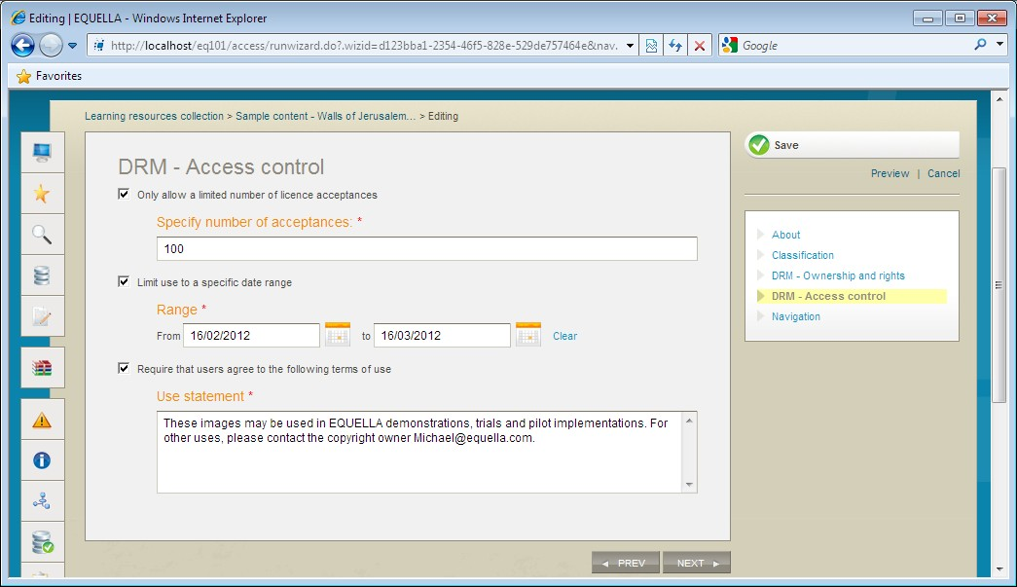

Figure 9 Collecting advanced digital rights information

A DRM licence with acceptance requirements can be displayed to users accessing content. An example is shown in Figure 10.
A user can choose to accept, reject or preview the terms.
Licence acceptances are recorded by EQUELLA enabling tracking for review by contributors and administrators.

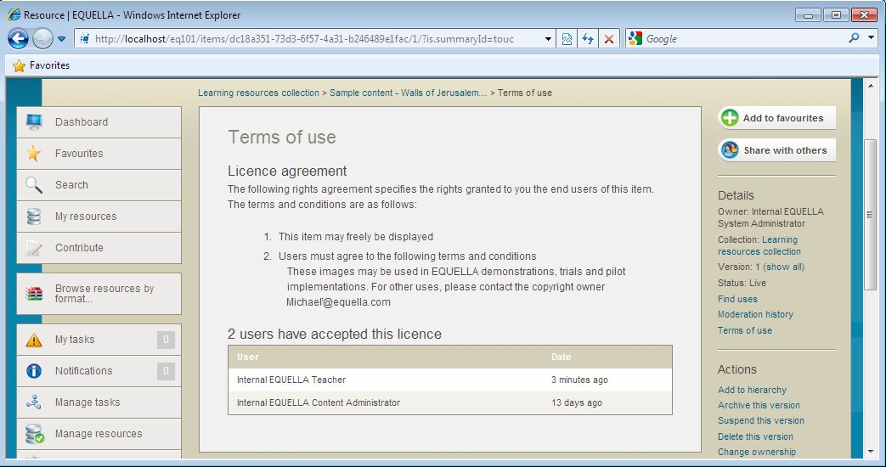

Figure 10 Terms of use page

Add DRM to an existing resource
- Create a new version of one of your resources.
- Select the Digital Rights Management (DRM) checkbox to add the DRM pages.
- Select and add details to the DRM – Ownership and rights page.
- Note the ways to limit usage of this resource on the DRM – Access control page:

- Add a Use statement.
- Save and Publish the resource to the EQUELLA Digital Repository.
- Read the conditions displayed on the Terms of use page then select Accept.
- Select the Terms of use link from the Details pane.
- Who has agreed to the licence conditions?
Review the section then complete the extension exercises if time permits
Extension exercises
- Create a new version of one of your resources.
- Select and change the details on the DRM – Ownership and rights page.
- Save and Publish the resource.
- Read the conditions displayed on the Terms of use page. Have they changed?

Further exercises (using the training institution)
1. Refer to (or continue with) the Further exercises section on page 42.

User profile
The Edit user page displays options that users can change including login notice, accessibility, notifications, language, time zone and date format settings.

Edit user profile exercises
- Select the Search button. Review how the Last updated date is displayed.
- Select the Edit user details button to display the Edit user page, shown in Figure 11.
<insert edit user image>

Figure 11 Edit user page

- Select to Enable accessibility mode.
- Select to be notified when live resources are added or edited in the Learning resources collection.
- Select the Exact date option from the Display date format drop-down list.
- Review the other options available.
- Select the Save button.
- Select the Search navigation menu option and review how the:
  - Drop-down list options and text input fields have changed in accessibility mode.
  - Last updated date has changed.

Further exercises
These exercises are intended to improve your familiarity with EQUELLA. Using the training institution, please continue with the exercises in this section as time permits.

Scrapbook
The Scrapbook page displays personal resources that can include files and web pages.
1. Select the My Resources button then Scrapbook option to display the Scrapbook
results list. An example is shown in Figure 12.

<insert scrapbook page image>

Figure 12 My resources | Scrapbook page

Upload files
Add a single resource exercise
- Select the Upload files link.
- Select the Browse button to search and select an image file.
- Select the Upload file button to upload the file.
- Select the Edit button and review the Edit file options.
- Enter a descriptive name and tags.
- Select the Save button.
- Review the changes.
Add multiple resources exercises
- Select the Upload files link.
- Drag n drop multiple attachments then select the Return to scrapbook button.
- Review the number of resources uploaded.
- Enter Tags then add a zip file then select an Archive extraction options drop-down.
- Select the Return to scrapbook button and review the number of resources uploaded.

Author web pages

Create web page exercises
- Select the Author new web pages link.
- Enter a Description then select the Add Page link.
- Enter a Title then enter text into the editor.
- Select the Embed EQUELLA Scrapbook Content button then the + button for your uploaded image file and OK.
- Save the page.
- Select the Edit button to display the webpage.
- Select the Add page link.
- Enter a page Title then select the Toggle full-screen link.
- Enter text into the editor then select the Insert EQUELLA Content button then select a resource to add a link to the editor.
- Select the Add page link.
- Enter a page Title then enter text into the editor.
- Select the Upload a file button then Browse and select a file.
- Select the Upload button to add a link in the editor.
- Save the page.
- Review all the added resources.

Find scrapbook resources
- Navigate to the Scrapbook page from the My resources portlet.

Use scrapbook resources
The personal resources saved in Scrapbook can be used when users are contributing published resources.
When users are selecting resource types to attach to contributed resources:
  - Scrapbook Files are accessed by selecting the Upload a file option then Import files from scrapbook link.
  - Scrapbook Web pages are accessed by selecting the Web pages option then Import files from scrapbook link.

Contribute a resource that includes scrapbook content exercise
- Contribute a resource to the Learning resources collection that includes a web page and file from your scrapbook.

Repository showcases

Common repository types
  - Teaching and Learning, and Research repositories
  - Copyright and Document Management
  - Content Production and Knowledge Management
  - Image Gallery
The following links provide access to a range of other EQUELLA repositories.
  - University of Canberra (Research repository)
http://www.canberra.edu.au/researchrepository
  - Griffith University
http://equella.rcs.griffith.edu.au/research
  - Utah Education Network (Multimedia)
http://eq.uen.org/emedia
  - University of Nottingham (fishbone collection) http://fishbone.nottingham.ac.uk
  - Florida Orange Grove (Content tagged to standards)
http://florida.theorangegrove.org/og
  - Oxford Brookes University (Research repository)
https://radar.brookes.ac.uk/radar
  - North Carolina Community College System
http://www.nclor.org/nclorprod
  - Royal Holloway, University of London
http://digirep.rhul.ac.uk

Use existing resources and content
Resources and content (attachments and links) associated with existing EQUELLA resources can be linked to other resources.
The EQUELLA select page allows users to search for and find resources in EQUELLA and link to them. The Home page features Search, Contribute, Browse, Selection and Recent: Favourites | Contributed | Selected options. An example is shown in Figure 13.

<insert equella home page image>

Figure 13 EQUELLA Home page

Select resources exercises
- Select the Contribute button then the Learning resources collection.
- Enter EQ101 existing resources<yourname> in the Title field.
- Enter An exercise using existing EQUELLA content in the Description field.
- Select the Media checkbox then select the Add a resource link.
- Select the EQUELLA Resource option then the Next button to display the EQUELLA
Home page.
- Note the search types available:
- Where would you find resources that you have previously contributed?
Search for existing resources
- Search for The Overland Track resource and view the resource summary.
- Note the four different options available to select resources to link to your resource. (Hint: mouse over the + signs):

Select existing resources
- Select at least 2 content attachments (parts) from the resource (e.g. Cradle, Lake Will).
- Select the Browse option then browse to find the EQUELLA Documentation resource.
- Select the Show attachment button.
- Select at least 2 attachments (one uploaded and one external resource) from the resource (e.g. Support Site, Overview).
- Select the Return selections button to display the My selections dialog.
- Will these resources be updated when a new live version is added to the repository?
- Select the Return selections button to add the selections to your resource.
- Preview the resource (Note: Temporarily allow pop-ups) then close the dialog.
- Save as a Draft resource.
- Review the resource summary and the added resources.
- Does the newly contributed resource appear in the results of a saved Favourite search?
- Create another resource using attachments from your computer, a YouTube video and existing EQUELLA resources.
- Find the EQUELLA Documentation resource then select the Find uses operation from the Details section.
- .Select the locations to add to:
  - Select the EQUELLA option from the Searching drop-down list to display a list of EQUELLA Linking resources that use this resource.
  - Select the Show details down arrows on the right of the listed resource to display Resource version, Date modified, Attachment, Name in external system and Owner details.
  - Find the <yourname> Documentation resource then select the Find uses
operation from the Details section.
  - Select the Moodle option from the Searching drop-down list to display a list of
Courses that use this resource.
  - Select the Show details down arrows on the right of the listed course to display Resource version, Date modified, Name in external system and course details.
- Find uses for the other resources you added to:
  - The Moodle course
  - EQUELLA resources.

EQUELLA Client support
- User level support—typically provided by a local support team lead by the system administrator. Contact your local support team as the first step to resolving user issues.
- Institution level support— <insert additional support info here>

Training Courses
EQUELLA provides the following training courses:
- EQ101—Core Principles (1 day workshop)
- EQ201—Content Administrator (1 day workshop)
- EQ301—Application Administrator (3 day workshop)
- EQ302—Advanced Application Administrator (1 day workshop)
- EQ303—Reporting Workshop (2-3 day workshop)
- EQ304—EBI Workshop (1/2 day workshop)
- EQ305—Scripting Workshop (1 day workshop)
- EQ306—Advanced Scripting Workshop (2 day workshop)
- EQ401—System Administrator (2 day workshop)

International User Community
The EQUELLA User Community enables members to contribute, share and stay connected with other users globally, while extending their knowledge of EQUELLA.
The following EQUELLA resources can be accessed:
- EQUELLA documentation
- Installer, upgrades, Internationalisation packs, sample reports and miscellaneous tools.
To join the EQUELLA User Community please see www.equella.com

