EQUELLA

EQ201 CONTENT ADMINISTRATOR WORKBOOK

Version 6.3

Table of Contents
Course Outline 5
Session 1 6
EQ201 introduction 6
Use existing resources and content 6
Create a navigation structure 8
Metadata schemas 10
XML example 11
Viewing XML information 11
Moderation workflow 13
Moderate a resource 15
Redraft a rejected resource 18
Manage moderation tasks 19
Notifications 20
Resource management 21
Manage resources 23
Session 2 28
Copyright compliance management 28
Contributing copied material 29
Use and activation of copied content 29
Managing activations 30
Generating copyright compliance reports 30
Activation 32
Manage the activations 32
Review activations 33
Manage external resources 34
Reports 36
EQUELLA bulk upload options 38
User profile 39
EQUELLA Client support 40
Training 40
International User Community 40
Repository showcases 41

Course Outline

This course is a practical exercise in understanding the EQUELLA Digital Repository. It is designed for users who manage resources in the EQUELLA Digital Repository. EQ201 covers the following areas of EQUELLA Digital Repository:
- Content Management
- Searching and indexing
- Resource structure and XML
- Creating a structure for EQUELLA resources
- Moderation Workflow
- Bulk Resource Management
- Content, Rights and Copyright Collections
- Bulk upload options
- Generate Reports
- User details
- EQUELLA support
EQ101 is a prerequisite for this and other EQUELLA courses.

A few important points about EQUELLA
- EQUELLA is customisable and therefore each educational institute can set up EQUELLA to suit their business needs. Often this makes learning EQUELLA seem confusing and complex at first as it is different to the supplied documentation.
- EQUELLA is privilege/permission based and different access privileges are given to different users. Some users can only search, others can add content or have control of the security (privileges). It is important that different users have different privileges, for example a student can only access exam questions while a teacher can also access the answers.
  - In EQ201 users are assigned Content Administrator role privileges and have access to administer other user’s resources.
  - Participants interested in extending their EQUELLA knowledge should join an EQ301 Application Administrator training course, which is a practical course in configuring an EQUELLA institution for organisational use.

Session 1

This session is to demonstrate and discuss:
- Creating a structure for EQUELLA resources
- Restricting attachments and Content management
- Searching and indexing
- Resource structure and XML
- Moderation workflow
- Bulk resource management

EQ201 introduction
To login:
- Navigate to <training url>/<training_id>
- Enter the username and password given to you by the trainer.
- Select Login then select OK for the Notice dialog to display the Dashboard page.

Use existing resources and content
Attachments and links associated with existing EQUELLA resources can be linked to other resources. Users can also organise resource content (attachments and links) into a structure with customised navigation (also known as sequenced content).
The EQUELLA select page allows users to search for and find resources in EQUELLA and link to them. An example is shown in Figure 1.
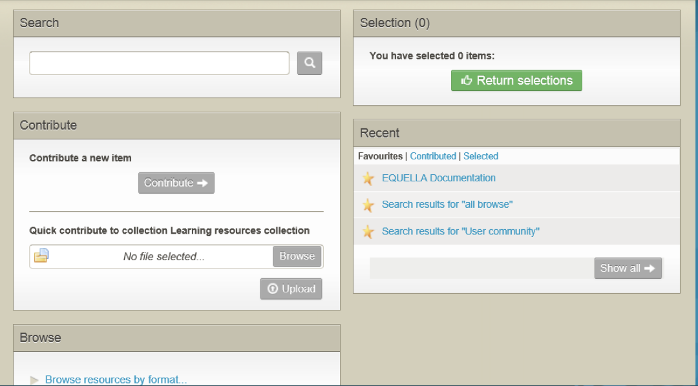

Figure 1 EQUELLA select page

Select resources exercises
In these exercises you will learn how to create a new resource using existing content.
Select existing EQUELLA resources
- Select the Contribute button then the Learning resources collection.
- Enter a Title (e.g. Structure example <yourname>) and Description.
- Select the Media checkbox then select the Add a resource link.
- Select the EQUELLA Resource option then Next button to display the Home page.

Search for existing resources
- Search for The Overland Track resource and view the resource summary.
- Note the four different options available to select resources to link to your resource. (Hint: mouse over the + signs):

- Select at least 2 attachments resources (e.g. Cradle, Lake Will).
- Select the Browse option then browse to find the EQUELLA Documentation resource.
- Select the Show attachment button.
- Select the EQUELLA Support link plus one PDF attachment (e.g. Overview) from the resource.
- Select the Return selections button to display the My selections dialog.
  - Selecting which Version option means resources will be updated when a new live version is added to the repository?
  - Selecting which Version option means the resources will always be linked to this version?
- Select the Return selections button to add the selections to your resource.

Add restricted resources
- Select the Add a resource link then select the Upload a file option.
- Select the Next button then add a Word document file (e.g. EQUELLA Overview.doc).
- Select the Next button.
- Check the Restrict box then select the Save button.
- Preview the resource (Note: Temporarily allow pop-ups)
- Is the file you restricted displayed?
- Select the Reorder attachments link and move the attachments.
- Save the reordering then close the preview and select Save Draft.
- Review the resource summary and note how the added resources are displayed.

Review the section

Create a navigation structure
In these exercises you will learn how to add structure to a resource.
Build a structure (sequenced content) exercises
- Find your draft resource (e.g. Structure example <yourname>).
- Select Edit this version in the Actions pane to display the contribution form.
- Select the Add a structure or sequence to the content checkbox to add the
Navigation page.
- Go to the Navigation page.
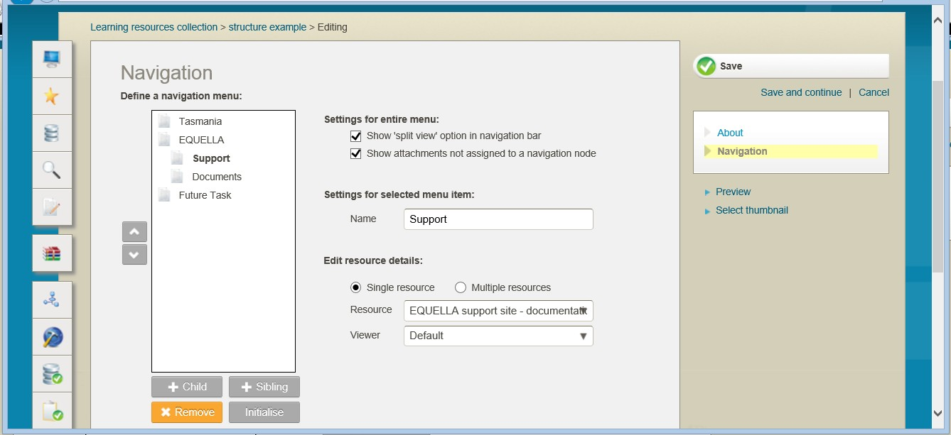
- Check the Show ‘split view’ option in navigation bar checkbox to allow users to view different tabs side by side. A completed example is shown in Figure 2.

Figure 2 Navigation page

- Select the Sibling button to add a folder.
- Enter a Name (e.g. Tasmania).

Add structure with multiple resources (tabs)
- Select Multiple resources option then Tab 1 link.
- Select a resource (e.g. Cradle) from the Resource drop-down list.
- Change the Name of the tab (e.g. Mountain) then select Save.
- Select the Add resource button.
- Select a resource (e.g. Lake Will) from the Resource drop-down list.
- Change the Name of the tab (e.g. Lake) then select Save.

Add structure with sub-folders
- Select the Sibling button to add a folder.
- Enter a Name (e.g. EQUELLA).
- Select the Child button to add a folder.
- Enter a Name (e.g. Support).

- Select Single resources option.
- Select a resource (e.g. EQUELLA Support) from the Resource drop-down list.
- Select the Sibling button to add a folder.
- Enter a Name (e.g. Documents).
- Select the Single resources option.
- Select a resource (e.g. Overview Whitepaper) from the Resource drop-down list.
- Preview the resource (Note: Temporarily allow pop-ups) then close the dialog.
- Save and Publish the resource to the EQUELLA Digital Repository.

To view the resource structure
- Select the Full screen link under the Links to resources section to display the structured resources.
- Select the resource title (e.g. Structure example <yourname>) to return to the resource summary.

To view restricted attachments
- Login using student Username and equella Password.
- Find your resource summary (e.g. Structure example <yourname>).
- Is the file you restricted displayed?

Review the section then complete the extension exercises if time permits

Extension exercises
1. Create a structured resource using attachments from your computer, a YouTube video and existing EQUELLA resources.

Metadata schemas
The information collected during contribution is in fact metadata and its fundamental purpose is to make content discovery and management easier.
Organisation of metadata is controlled by the metadata template called a Metadata Schema. A metadata schema:
- Typically comprises a number of elements or nodes arranged in a hierarchy.
- Provides a structure for information that is copied each time a new resource is contributed.
- Provides a map for EQUELLA to enable it to find or store the required information.
- Written using XML (Extensible Markup Language)
- Schemas are used in collections, workflows and searching.
Schemas provide structure and organisation to data. It ensures that there are consistent labels and locations for data stored with resources.
Standard schemas have been developed to improve the reusability of digital materials between repositories. Commonly used standards are Learning object metadata (LOM) (http://www.imsglobal.org/metadata/mdv1p3/imsmd_bestv1p3.html#1621612), and Dublin Core (DC) (http://dublincore.org/documents/dces/).

EQUELLA Metadata Schema editor
EQUELLA provides an editor for creating schemas and places no restrictions on their structure. EQUELLA implements all schemas using XML enabling:
- Translation or mapping of metadata from one schema to another using XSLT.
- Importation of existing XML schemas.
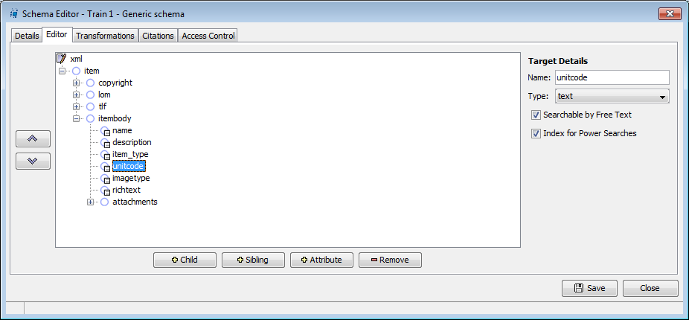

Figure 3 Metadata schema

Locating XML information
XML information is located in nodes (sometimes called elements). To find the data in a node a consistent means of describing the location of each node is needed. This is called the Xpath and describes all the nodes that surround the data from the top down e.g. item/itembody/unitcode.

XML example
XML is a text file that comprises tags that mark out data. XML files comprise a lot of
‘visual noise’ but they are only structured text files that have data surrounded by tags.
Within an XML file a start tag and end tag pair define an element, commonly called a node. An element can comprise data; data and attributes; or child elements, data and attributes.

A simple element
<description lang=”en-AU”>This resource comprises electron microscope images of water microbes.</description>
This element comprises data and attributes:
- Data—the text that appears between the start and end tag, This resource comprises electron microscope images of water microbes.
- Attributes—any name=value pair that appears inside the start tag, in this example
lang=”en-AU”.

Viewing XML information
EQUELLA resources, their attachments and XSLTs can be viewed by inserting a tildé character ‘~’ immediately after the version number in the URL e.g.
http://myequella.edu.au/learning/resources5b0dbc71-b444-3789-d6e5/2/~

Resource structure and XML exercises
In these exercises you will learn about components of the URL and resource XML.

Contribute a resource
- Find your resource (e.g. Structure example <yourname>) and view the summary.
- Edit the resource and attach a file.
- Add applicable Classification information (metadata).
- Save the resource.
- Browse to find the resource and view the summary.

Components of the EQUELLA URL
- Note the 4 components of the URL.
  - EQUELLA server name_
  - Institution name
  - Resource unique ID
  - Version number

Resource XML
- Use the tilde (~) to view the resource XML and parts.
- What is listed on the page?
- Why is the attached file the only resource content that is listed?

Resource and system metadata
- Use <XML> to view the resource and system metadata.
- Note the two ways to do this:

Generated XML
The displayed XML will be a combination of:
- entered metadata and
- system generated metadata.
The system generated XML nodes are appended to the resource metadata schema and cannot be accessed when editing a schema. System generated XML contains system related information such as:
- resource ID
- version number
- date of creation or editing
- workflow steps

From the resource’s XML:
- Note an example of system generated XML

- Note an example of user entered metadata

Review the section then complete the extension exercises if time permits

Extension exercises
1. Find the EQUELLA Documentation resource then repeat the exercises. This exercise is intended to improve your familiarity with your EQUELLA.
- Login to your EQUELLA (not the training institution) then find a resource.
- Repeat the exercises from the Components of the URL section.

Moderation workflow
Workflows are associated with a collection and can be a simple one-step review or complex multi-step editorial and technical review comprising multiple publication paths.
EQUELLA automatically notifies users when they must review or moderate a repository resource.

Users can review their resource’s moderation status from the:
- My resources | Moderation queue page—displays resources currently waiting for moderation for the logged in user.
Moderators can be notified about tasks in various ways including:
- Tasks portlet—displays the number of pending tasks.
- My tasks page—displays the tasks waiting to be moderated, shown in Figure 4 on page 13.
- RSS feeds—displays updated information about tasks and notifications.
- Notifications page:
- Moderation overdue—notification displayed when the date for the current moderation task has passed.
- Rejected—notification displayed when a resource has been rejected during a moderation task.
- Notifications portlet:
- Resources that are overdue to be moderated—notification displayed when the date for the current task to be moderated by has passed.
- Resources that were rejected—notification displayed when a resource has been rejected during a moderation task.
- Notification emails—sent to alert the user to new notifications, moderation tasks and when moderation is overdue.

Content administrators can manage resource progress through moderation from the:
- Manage tasks page—displays the moderation progress of all moderation tasks.
- Task statistic portlet—displays information relating to the number of tasks in a workflow over a weekly or monthly time period.

<insert image of My tasks page>

Figure 4 My tasks page

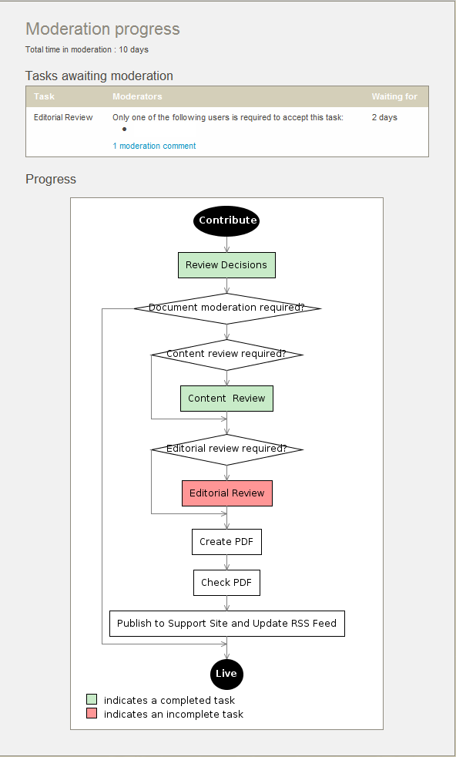
Once the moderators have completed their review the next step in the workflow is determined by the moderator’s responses. The moderation progress and history pages display the resource’s moderator details, all task review events and moderation progress, an example is shown in Figure 5.

Figure 5 Moderation progress

Resources enter a workflow when they are:
- Contributed—the resource enters the workflow associated with the contributed collection.
- Versioned—a new version enters the workflow and on completion archives all other ‘live’ versions.
- Reviewed—a resource that has been ‘live’ for some period is checked for currency. The resource remains searchable during this review.
Further information is provided in the EQUELLA Moderation Workflow User Guide.

Moderation workflow exercises
In these exercises you will add a resource to the training moderation workflow and moderate it at two different tasks.

Contribute a resource
- Contribute a resource (e.g. Moderation example<yourname>) to the Learning resources collection.
  - Attach a Word Document.
- Select the Save button and add a message for the moderator (e.g. please check the attached document).
- Select the Submit for moderation button.

Share with others
For moderating resources, the Share with others function enables the user to set up a notification to be sent to selected EQUELLA users when the resource status becomes Live, so they are aware that the resource is available for use.
- Select the Share with others button then the Select more users to notify link.
- Use a letter, partial name or name to search and find then Select these users to notify all the other users in the class (including yourself) about this resource.

Review the section

Moderate a resource
To moderate the first task
- Select the Tasks button to display the My task page with a list of resources you can moderate.
- The list can be sorted by:
- Familiarise yourself with the filters that can be applied.
- Filter the list to Assigned to me then Clear the filters.
- Select the Select user button to filter the list to only include your resources.

- For the resource (e.g. Moderation example<yourname>) note the:

Status
  - Task and Expiry date
  - Time at this task
  - Priority
  - Read the moderation comment then close the dialog.
- Select the Moderate button to display a Task pane.
- Read the task description.
- View the list of moderators for this task.

To assign and review the task
- Select assign to me to assign the task to yourself.
- Select the View summary button.
- Note the:

Version
  - Status
- Select Moderation progress from the Details pane.
- Review the information this page provides.
- Select the View metadata button to display the un-editable contribution form.

To edit the resource
- Select the Edit resource button to display the editable contribution form.
- Review the information (metadata) and make a change to the title or description.
- Select the Edit link for the attached document to display the Upload files from your computer dialog.
- Select a File editing option to open the document then make a change and save.
- Select the Upload changes button then the Save button.
- Select the Classification information checkbox to add the Classification page.
- Go to the Classification page then add some applicable information.
- Select the Save button to save the edited resource.

To approve the task
- Select the Approve button.
- Note the comments previously added then enter an applicable Approving task
message.
- Select the Submit button.

Review the section

To moderate the next task
- Select the Tasks button to display the My task page with a list of resources you can moderate.
- Find your resource (e.g. Moderation example <yourname>) then review the information.

To review and assign the task
- Select the Moderation progress link.
- Review the information this page provides and note the completed and current tasks.
- Read the task description.
- View the list of possible moderators for this task.
- Why is this task already assigned to me?
- If you had not been a moderator at the previous task, would the task be assigned to anyone or unassigned?_
- Note the:

Version
  - Status
- Select Moderation history from the Details pane.
- Review the information and read the comments that have been added.
- Note the moderation task that has just been accepted
- Select the View metadata button to display the un-editable contribution form.

To reject the task
- Select the Reject button.
- Add a mandatory comment.
- Select the Original Contributor from the Rejection back to drop-down list.
- Note the other rejection destination list option
- Select the Submit button to confirm the rejection.

Review the section

Redraft a rejected resource
To re-enter a workflow the Redraft action must be used.

To find the rejected resource
- Select the Dashboard button to display the Dashboard page.
- List 2 places where notifications are shown:

- Review the All notifications section of the Tasks portlet.
- Select the Resources that were rejected notification category.
- Select the Notifications button to display the Notifications page with a list of resources that have been rejected or you were notified about.
- Which filter has been applied and why?
- Select the resource (e.g. Moderation example<yourname>) title to display the resource summary page.
- Note the:

Version
  - Status
- Select Moderation history from the Details pane to display the Moderation history list.
- Select the Show comment link and read the Rejected comment.

To redraft the resource
- Select the Include all moderation details option.
- Select the Redraft this version option from the Actions pane.
- What will happen when the following options are selected?

Redraft
  - Edit this version
  - Create a new version
- Review the information (metadata) and make a change.
- Complete the form then Save and resubmit the resource into the moderation workflow.
(NOTE: the Rejected notification is automatically cleared when the resource has been redrafted.)

Review the section

Manage moderation tasks
Content administrators can manage the progress of resources through multiple moderation processes.
Tasks can be managed from the:
- Tasks Statistics portlet and
- Manage tasks page.

Task statistics exercises
In these exercises you will learn about task statistics.
- Add a Tasks statistics portlet to your Dashboard page.
- Review the Tasks statistics portlet on your Dashboard page.
- Select Weekly trend:
  - Review the number of resources currently Waiting moderation at each task.
  - Review the Trend changes from the previous week.
- Select Monthly trend:
  - Review the number of resources currently Waiting moderation at each task.
  - Review the Trend changes from the previous month.

Manage tasks exercises
In these exercises you will learn about managing tasks.
- Select the Manage tasks button to display the Manage task page with a list of resources manage.
- Review the information provided to the tasks manager.
- Select the Share tab and review the options provided.
- The list can be sorted by:
- Filter by moderator to only display your resources.
- Select the <x> remaining moderators link to display the moderators list.
- Select the resource (e.g. Moderation example<yourname>) title to display the

Moderation progress page.
- Select the Manage tasks button to display the Manage task page.

Review the section

Notifications
Notifications are messages related to a moderation workflow including when a task has been has been rejected, moderation is overdue or a resource becomes Live.
Notifications are available from the Notifications section of the Tasks portlet and
Notifications page and include:
- Moderation overdue—current task moderation date has passed. These notifications are automatically cleared once the overdue task is moderated.
- Watched resource became LIVE—a resource belonging to a collection selected for notifications has become Live. These notifications are cleared manually.
- Bad URL—a resource contains a URL that has an invalid web address. These notifications are automatically cleared once all bad links are corrected.
- Owner notified you—the owner has notified the logged in user that a resource has become available Live. These notifications are cleared manually.
- Rejected—a resource has been rejected during a moderation task. These notifications are automatically cleared once the associated resources have been redrafted.

Notification exercises
- Moderate your resource and publish it. (It should have a Live status.)
- Have you received any notifications about resources going Live?
- List 2 places where these notifications are displayed
- Note each Reason on the Notifications page and find its corresponding link in the
Notifications list of the Tasks portlet:

Review the section then complete the extension exercises if time permits
Extension exercises
- Add a resource to a workflow collection then reject it.
- Edit the rejected resource then create a new version to ensure you understand the differences.
- Refer to the EQUELLA Workflow Moderation User Guide.
This exercise is intended to improve your familiarity with your EQUELLA.
- Login to your EQUELLA (not the training institution).
- Repeat the exercises from the Moderation section.

Resource management
Content administrators can manage resources, either individually or as bulk actions, regardless of ownership.
Resources can be managed:
- Individually from the resource’s summary page.
- As bulk actions from the Manage resources page.

Resource summary exercises
In these exercises you will learn about managing resources in EQUELLA. Resources can be managed individually from the resource summary page.
1. Find the EQUELLA Documentation resource and view the resource summary.

Details pane
The Details area of the resource summary displays information about the resource.

Find uses option
The Find uses page displays a list of the current uses of this resource in a connected LMS (Moodle or Blackboard Learn) course or EQUELLA resources.
- Select Find uses from the Details pane.
- Select EQUELLA from the Searching drop-down list.
  - Review where the content from this resource is being used.
  - Select the Show all versions of this resource checkbox.
  - Select the Include non-live items checkbox.

History option
- Select Moderation history option from the Details pane.
- View all edits, details and comments.

Review the section

Actions pane
The Actions area of the resource summary displays options for editing and managing the resource.
1. Find your resource (e.g. Structure example <yourname>) and view the resource summary.

Key resource option
Key resources are important resources for a browse hierarchy topic and are displayed at the top of the results list. Resources can be added as key resources to one or more hierarchy topics.
- Select the Modify key resource option from the Actions pane.
- Browse the hierarchy topics then select the applicable checkbox.
- Select the Save button.
- Navigate to the Browse hierarchy topics and find your resource.
- What special type of resource has this resource been added as?
- Remove this resource as a key resource from the hierarchy topic.
- What other options would be applicable hierarchy topics for this resource?

Export option
- Find your resource (e.g. Structure example <yourname>) and view the resource summary.
- Select the Export option to display the Export page.
- Note the formats that can be used when exporting this resource:

Review the section

Manage resources
Bulk management actions can be performed on the Manage Resources page (accessed through the Manage Resources button). An example is shown in Figure 6.

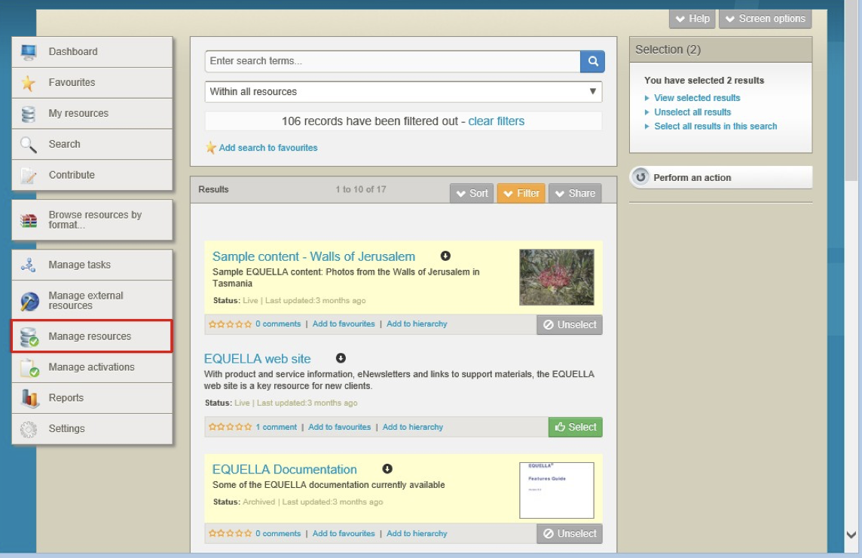

Figure 6 Manage resources page

Actions that can be carried out include:
- Re-draft—returns the selected resources to Draft status.
- Submit for Moderation—submits the selected Draft resources to the moderation queue.
- Delete—removes resources from the repository, sets the resource status to Deleted
and marks it for purging with the next scheduled purge task.
  - Restore—sets the Deleted resource status back to Live.
  - Purge—permanently removes Deleted resources. It is irreversible and purged resources cannot be recovered as they are removed from the database.
- Archive—changes a Live status to Archived.
  - Make live—sets the Archived resource status back to Live.
- Reset Workflow—restarts the Moderation Workflow.
- Suspend—sets the selected resources to Suspended which hides the resource from searches and is intended for temporary removal of resources from the repository
  - Resume—sets the Suspended resource status back to Live.

- Review—puts a resource back into a Moderation Workflow and sets the resource status to Review. It is intended for resources that have completed a workflow and allows resources in the live state to be checked for currency.
- Change Owner—allows the resource owner to be changed to another EQUELLA user.
- Clone—allows a resource to be duplicated without saving the history of the original resource.
- Move—allows a resource to be transferred to a new Collection.

(Note: Care is required when using these actions.)
Further information is provided in the EQUELLA Manage Resources User Guide.

Resource administration exercises
In these exercises you will learn about managing all resources in EQUELLA.
- Select the Manage resources button to display the Manage resources page.
- Filter the list to Live resources.
- Reduce the number of resources by:
  - Search terms (e.g. equella).
  - Collection (e.g. Learning resources collection).
  - A different status.
  - Date last modified.
- Clear the filters.
- Which search criteria were not removed?
- Remove the search terms and options.

Advanced Management exercises
- Select the Learning resources collection from the Within drop-down list.
- Select the +Add criterion button to display the Add search criteria dialog.
- Enter a query using the operators (e.g. Where item/lom/technical/format is video).
- Select the Add criterion then Search button to find resources.
- Select the Edit query button and add extra criteria (e.g. AND
item/itembody/imagetype is Colour photo).
- Select the Add criterion then Search button to find resources.
- Clear the query then search terms and options.

Review the section

Perform an action
In these exercises you will learn about bulk actions.
- Filter by owner to only display your resources.
- Clone a Live resource and select the Draft option.
- Clone a Live resource and select the Moderating option.
- View the Moderation history for the original resource and the cloned resources and compare.
- Select the Manage resources button to display the Managed resources page.
  - Is the list still filtered by owner?
- Move a resource.
  - How is this different to a cloned resource?
- Delete a resource.
  - What happens if the resource is Purged?
  - Restore the resource.
- Change ownership of a resource to another class member.
  - Why is the resource not listed in the Manage resources results list?

  - To find the resource in the Manage resources results list you would have to?

- Archive one of your resources.
  - What status does a resource have to be before it can be archived?
  - Make the resource Live again.
- Re-draft a Live resource.
  - Note the resource status and version
- Change a resource to Review status.
- Create a new version for a Live resource.
  - Note the resource status and version
- Edit the new versioned resource.
  - Note the resource status and version

View resources currently in a moderation
- Filter the resource using the Only show resources in moderation checkbox.
- Which other Filter by section is displayed?
- List the resource status types:

Filters
- Review the filters available.
- When would you use the Show items with no owner option?

Actions exercises
In this exercise you will compare the actions that are available using the Manage resources page and through a resource summary page.
- Find one of your Live resources and view a resource summary.
- What Actions are available to a Content Administrator?

then

then or

  - then

- Which Actions are only available through the:
  - Manage resources page

  - Resource summary page

Review exercises
- Search for all resources in the repository.
- List the resource status types:

- Where would you find Archived resources:
  - As an owner?
  - As a Content administrator? Filter by
- Where would you find Moderating resources:
  - As an owner?
  - As a Content administrator? Filter by
- List the workflow status types that can be displayed on the My task page:

- List the workflow status type that can be displayed on the Notifications page:

Review the section then complete the extension exercises if time permits

Extension exercises
- Find the EQUELLA User Community resource and remove a comment.
- Refer to the EQUELLA Manage Resources User Guide.

This exercise is intended to improve your familiarity with your EQUELLA.
- Login to your EQUELLA (not the training institution).
- View the actions available from a resource summary for a resource you own.
- Review all actions in the Bulk actions dialog. Recall that care is required for actions.

Session 2

This session is to:
- Demonstrate and discuss:
- Content, rights and copyright collections
- Generate reports
- Bulk upload options
- User details
- EQUELLA support

Copyright compliance management
EQUELLA supports the concurrent use of Australian Copyright Agency Limited (CAL) and the United Kingdom Copyright Licensing Agency Limited (CLA) agreements.
The EQUELLA copyright compliance features include the ability to activate specific attachments (typically book chapters and journal articles) for particular periods within a course to ensure compliance with local copyright laws. EQUELLA automatically tracks content usage of the activated resources and produces the appropriate reports, reducing the reporting work load for institutions.
The copyright features provide custom activation error messages and copyright status agreements for display to users.
Further information is available in the EQUELLA Copyright (CAL & CLA) Enhancements Overview Guide.

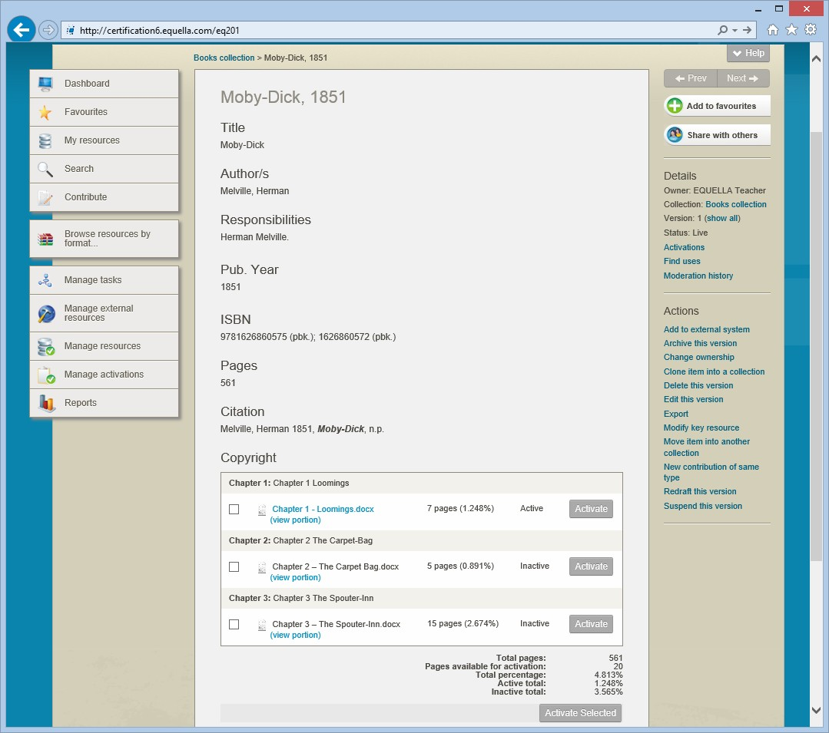

Figure 7 Active and inactive portions that are linked to a parent resource

Contributing copied material
Copyright resources are contributed to the repository through interrelated collection definitions. Typically a parent resource (source book or journal details) is contributed to a holding collection then the sections (copied or electronic book chapters or journal articles) are added to the portion collection and linked to the parent resource in the holding collection.
The remote repository search features allow users to search for source details from a variety of external sources and automatically add them to EQUELLA.

Use and activation of copied content
There are no restrictions on the amount of copyright content that can be contributed to the repository but it cannot be used until it has been activated. Content is activated when it is added to a course. Activation signals to the copyright compliance module that content usage should now be recorded and copyright compliance enforced. If the activation violates the copyright requirements, an error message is displayed and the content will not be made active. Once activated the content is viewable by course users.

The copyright states include:
- Inactive—not currently activated
- Active—currently activated
- Pending—date set for future activation.

Managing activations
Resource activations can be tracked by content contributors and deleted, deactivated or rolled over for future courses by administrators.
Multiple or individual resources can be:
- Deactivated—if they are not required prior to the end of the activation period.
- Deleted—if they have been incorrectly activated.
- Rolled-over—if they are required for a new time period, for the same or different course.
Activation details are stored in the portion resource’s unified xml.

Generating copyright compliance reports
EQUELLA generates reports that show all activated content for the reporting period. These reports are provided in a CAL or CLA format.

Notes

Copyright exercises
In these exercise you will learn about holdings, portions, activations and managing copyright resources.
The Books collection used in the following sections has been set up using 10% (default) as the Part VB book percentage.

Contribute a holding resource
- Select the Books – Libraries Australia source from the Contribute page.
- What type of repository are you searching?
- Enter search terms (e.g. Global education) then select the Search button.
- Select a result to display the information page.
- Select the Import button to display the contribution form.
- Add <yourname> to the beginning of the Book Title (Note: this is only something for this training).
- Ensure all the mandatory fields are completed.
- Make the Total number of pages for this book a number (e.g. 100).
- Save and Publish the holding resource.
- Review the Copyright section at the bottom of the summary page.

Contribute a portion resource
- Select the Contribute button to display the Contribute page.
- Select the eReserve articles collection in the Copyright category to display the contribution form.
- Add an attachment (e.g. Global Education Overview.pdf).
- Enter a Page range (e.g. 1-10).
- Select the Type (e.g. Book extract).
- Search and select the Book (e.g. <yourname> Education for a global society).
- Select the Select item button then Return selection button.
- Select the Save button to link the holding resource to the portion contribution form.
- Enter Chapter number (e.g. 1).
- Enter a Title (e.g. Overview <yourname>)
- Save and Publish the portion resource.
- Review the Copyright section at the bottom of the summary page.
- Can the attachment be accessed?

Review the section

Activation
Activate a portion resource
- Select the Manage activations button from the navigation menu to display the
Manage activations page.
- Are your resources currently displayed on this page?
- Find the holding (parent) resource and select it to display the resource summary page. Note the:

Total pages
  - Pages available for activation
  - Total percentage
  - Active total
  - Inactive total
- Check the box for the portion resource then the Activate button to display the

Activate attachments page.
- Select a Course then Search for a course (e.g. EQ201) then select OK button.
- Select dates to Activate from and until.
- Select the Activate button to display the holding (parent) resource. Note the:

Total pages
  - Pages available for activation
  - Total percentage
  - Active total
  - Inactive total
- Which resource is active, the portion (section) or the holding (parent)?

Manage the activations
- Select the Manage activations button from the navigation menu to display the
Manage activations page.
- Find your activated portion resource using the Filter by owner filter.
- Note the:

Course
  - Activated From date
  - Activated Until date
  - Copyright Status
- Select the Select button for the resource.
- Review the actions available in the Selection pane.
- Select the Perform an action button.
- Note the Bulk actions that are available:

- Select Rollover Activations from the drop-down list then the Next button.
- Select a different Course from the drop-down list.
- Check to Deactivate existing.
- Select future Start date and End date.
- Select the Execute button then OK and the Close Window button.
- Find your portion resource:
  - How many times is it listed?
  - Note the copyright Status for each listing of your resource
  - Review the differences for the two results.
- Why is the holding resource not listed in the Manage Activations results list?

- What Status will resources listed in the Manage Activations results list have?

Review activations
- Search to find your portion resource’s summary page.
- Select the Activations option from the Details pane to display the Activations
page.
- Note the information listed on the page.
- Select the Edit link for the Active portion. Which settings can be changed?

- Select the Edit link for the Pending portion. Which settings can be changed?

- Find your holding resource.
- Review the information listed on the Activations page.
- Is it different to the information on the portion resource’s Activations page?

Review the section then complete the extension exercises if time permits
Extension exercises
- Add another portion resource and link it to your holding resource.
- Can you activate it?
- If a portion resource is linked to an LMS but it is not activated will students be able to view it?
- View the resource XML using the ~.
This exercise is intended to improve your familiarity with your EQUELLA.
- Login to your EQUELLA (not the training institution).
- Compare your available options with those from your training institution.

Manage external resources
The Manage external resources function enables users to manage EQUELLA resources or resource attachments that have been added to an LMS (Moodle and Blackboard) or another EQUELLA resource. The results list displays information such as the EQUELLA resource name, EQUELLA attachment name, Course name, course Location and Enrolments. An example with results from a Moodle connector is shown in Figure 8.

<insert Manage external resources image>

Figure 8 Manage external resources—Moodle

When more than one connector is configured a drop-down list displays the options before results are displayed. The options include:
- EQUELLA—displays EQUELLA resources and resource attachments that are linked to other EQUELLA resources. The results can be sorted and filtered.
- Moodle—displays EQUELLA resources and resource attachments that are linked to Moodle courses. The results can be sorted and filtered. The resource and attachment LMS names can be edited and links deleted. Multiple resources can be deleted and moved in bulk actions.
- Blackboard—displays EQUELLA resources and resource attachments that are linked to Blackboard courses. The resource and attachment LMS names can be edited and links deleted. Multiple resources can be deleted and moved in bulk actions.
- Canvas—displays EQUELLA resources and resource attachments that are linked to Canvas courses.

Manage external resources exercises

EQUELLA resources
- Select the Manage external resources menu button to display the Manage external resources page.
- Select EQUELLA option from the Within drop-down list to display a results list.
- Review the type of information displayed.
- The results list can be Sorted by?
- The results list can be Filtered by?

LMS resources
- Select Moodle option from the Within drop-down list to display a results list.
- Review the type of information displayed.
- The results list can be Sorted by?
- The results list can be Filtered by?
- Select the Select button for a resource.
- Review the actions available in the Selection pane.
- Select the Perform an action button.
- Note the Bulk actions that are available:

Bulk actions
- Move—this action moves the selected resources from the current location within the associated LMS to the ones selected in the Move dialog.
- Remove—this action removes the selected resources from their location within the associated LMS. They are also removed from the Manage external resources results page.
1. Select the Move action then the Remove action and review the functions.

Extension exercises
This exercise is intended to improve your familiarity with your EQUELLA.
- Login to your EQUELLA (not the training institution).
- Compare your available options with those from your training institution.

Reports
New reports can be created using the BIRT report designer available from the EQUELLA support site. Using BIRT requires experience with SQL.
Reports with parameters require a user to input variables such as date ranges to filter results.
Parameters can also be used to pass variables to another report and allow users to generate further reports or get more information about a resource listed in the report.

<insert Sample reports image>

Figure 9 Sample reports

Reports can be generated in HTML, PDF or Excel format and can be printed.
(NOTE: reports should not be run during peak times as generating large reports can impact on system performance.)

Notes

Report exercises
In these exercises you will learn about generating reports.

Run reports
- Select the Reports button to display the Reports page.
- Select the Sample Reports link then the OK button.
- Select the Top searches queries report link to generate the report.
  - Select the Edit parameters button and change the parameters.
  - Select the Execute Report button.
  - Select a resource to display a sub-report.
  - Select the Show as… drop-down list. Note the default format
  - Change the sub-report to PDF format.
  - Change the sub-report to Excel format.
- Change the Show as… drop-down list to HTML format.
- Generate the Top 10 users by login report.
- Select other reports and find a report:
  - With parameters
  - That drills down to another report

Review the section then complete the extension exercises if time permits

Extension exercises
This exercise is intended to improve your familiarity with your EQUELLA.
- Login to your EQUELLA (not the training institution).
- Select Reports:
  - Review the available reports.
  - Discuss when to run the reports with your system administrator. Some reports can be resource intensive on large systems.
- Compare your available options with those from the training institution.
  - Note any differences.
  - How will the differences affect your content management role?

EQUELLA bulk upload options
The multiple options for bulk loading data into EQUELLA include:
- Java utilities—there are two utilities that allow resources, or resources plus attachments, to be exported and imported.
  - Export tool—exports records from a collection as XML files plus linked attachments. The original resources and attachments remain in the original collection.
  - Import tool—reloads the exported files into another EQUELLA collection or different server as long as both schemas match.
- Custom programming—gives an organisation or institute flexibility in exporting and importing data from legacy systems to EQUELLA. Typically it is programs that are written by an EQUELLA consultant to client specifications.
  - Python (an open source computer language) is the preferred scripting language for these activities. Python uses SOAP calls that can manipulate existing EQUELLA XML or create and upload new XML and can be used to upload attachments.
  - The EQUELLAizer is a Moodle Content Harvester that allows users to utilise the EQUELLA SOAP API to read a Moodle course backup. Users can upload local Moodle content to EQUELLA as resources with attachments, adding metadata nodes and values as required.
- EQUELLA Bulk Importer (EBI)—creates EQUELLA resources from data contained in a CSV file, an example is shown in Figure 10. The EBI:
- Creates EQUELLA resources from data contained in a CSV file.
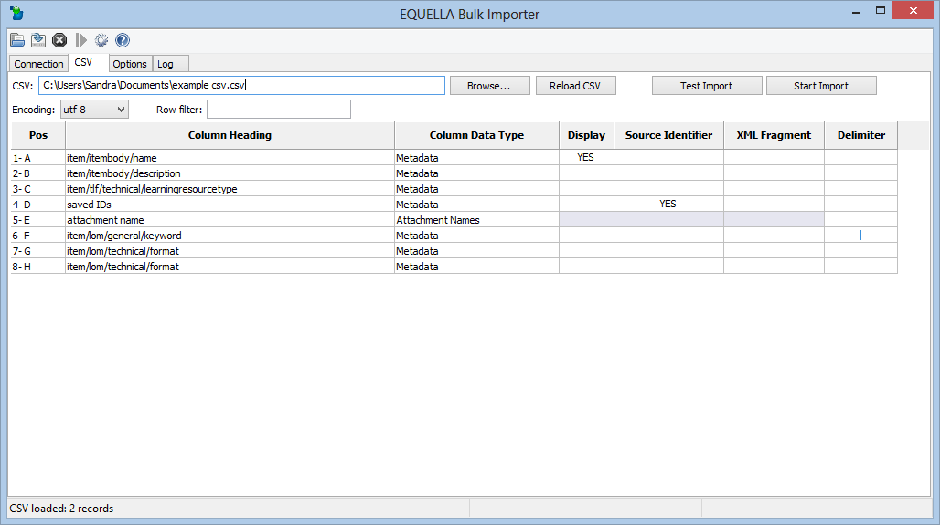
- Uses XML paths to configure where the data is stored.

Figure 10 EBI

User profile
Editable details can include notifications and language settings.
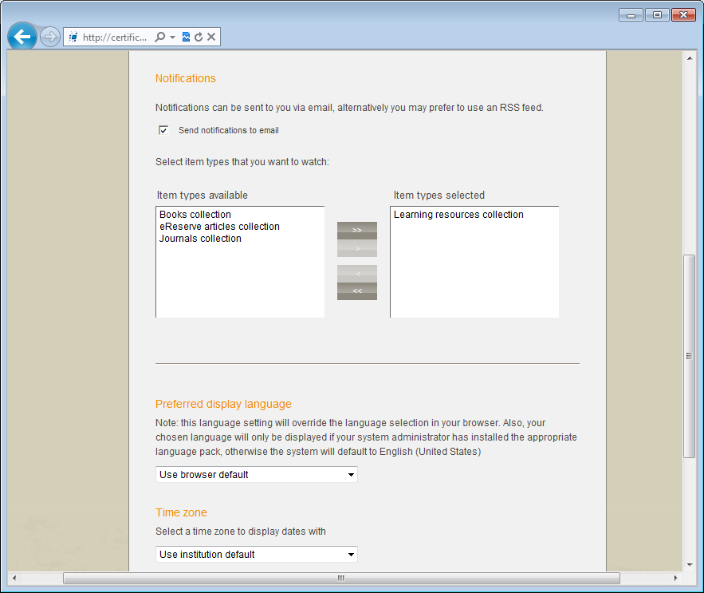

Figure 11 Edit user page

Profile exercises
Edit user details
- Select the Edit user details link to display the Edit user page.
- Select the Send notifications to email checkbox to receive moderation workflow notifications. Selecting this option sends an email to the user when a new moderation task is added. Uncheck this option to switch off email notifications (except moderation overdue messages).
- Select the Teaching resources collection checkbox to be notified when live resources are added or edited in the collection.
- Review the options available.
- Add a resource to the Teaching resources collection.
- Where did you receive a notification about the Live resource?
Extension exercises
- Login to your EQUELLA (not the training institution).
- Select the Edit user details link to display the Edit user page.
- Compare your available options with those from your training institution.
  - Note any differences.
- How will the differences affect your content management role?

EQUELLA Client support
- User level support—typically provided by a local support team lead by the system administrator. Contact your local support team as the first step to resolving user issues.
- Institution level support—<insert additional support info here>

Training
EQUELLA provides the following training courses:
- EQ101—Core Principles (1 day workshop).
- EQ201—Content Administrator (1 day workshop).
- EQ301—Application Administrator (3 day workshop).
- EQ302—Advanced Application Administrator (1 day workshop).
- EQ303—Reporting Workshop (2-3 day workshop).
- EQ304—EBI Workshop (1/2 day workshop).
- EQ305—Scripting Workshop (1 day workshop).
- EQ306—Advanced Scripting Workshop (2 day workshop).
- EQ401—System Administrator (2 day workshop).

International User Community
The EQUELLA User Community enables members to contribute, share and stay connected with other users globally, while extending their knowledge of EQUELLA.
The following EQUELLA resources can be accessed:
- EQUELLA documentation
- Installer, upgrades, Internationalisation packs, sample reports and miscellaneous tools.
To join the EQUELLA User Community please see www.equella.com

Common repository types
- Teaching and Learning, and Research repositories
- Copyright and Document Management
- Content Production and Knowledge Management
- Image Gallery

Repository showcases
The following links provide Guest access to different EQUELLA clients around the globe. Discover how they are utilising the digital repository for a range of diverse requirements.
- University of Canberra (Research repository)
http://www.canberra.edu.au/researchrepository
- Griffith University
http://equella.rcs.griffith.edu.au/research
- Utah Education Network (Multimedia)
http://eq.uen.org/emedia
- University of Nottingham (fishbone collection)
http://fishbone.nottingham.ac.uk
- Florida Orange Grove (Content tagged to standards)
http://florida.theorangegrove.org/og
- Oxford Brookes University (Research repository)
https://radar.brookes.ac.uk/radar
- North Carolina Community College System
http://www.nclor.org/nclorprod
- Coventry University
http://curve.coventry.ac.uk/cu
- Royal Holloway, University of London
http://digirep.rhul.ac.uk

