EQ302 Exercise Name:

In order to complete your EQ302 Training, you will need to answer both practical and written questions. Multiple choice and short answer questions as well as a series of practical tasks are set below and you will need to complete them individually. Access to the EQUELLA institution will be given to you by your instructor.
You will be assessed in a variety of tasks, such as Security, Search and Item Display Summary modification, Troubleshooting, Scripting and Reporting. When making any changes to the Security model, please implement these following the best practice guidelines that have been discussed.

Multiple-choice & short answer questions
For the multiple choice questions, please tick all answers that apply (may be one or multiple).

Multiple-choice (tick all answers that apply)

  - Which of the following tasks are done in the Institution Manager?
    - Upgrade the license
    - Import an institution
    - Clone an item
    - Edit any user’s role login/password details

  - When creating an expert script within the collection definition, what 2 options are available?
    - Save Script & Remove Script
    - Save Script & Newversion Script
    - Save Script & Load Script
    - Save Script & SOAP API Script

  - Which of the following security statements are true?
    - EQUELLA ACLs provide a hierarchy of inherited privileges
    - Override should be used as much as possible
    - Permissions are ideally assigned to roles, not groups and users.
    - In the absence of an explicit Revoke, there is an implicit Grant

  - Which of the following statements are true? If false, please clarify below why these are false:
    - EQUELLA does integrate with LDAP to authenticate external users

    - When LDAP is enabled, local users cannot login to EQUELLA any longer

    - TLE_ADMINISTRATOR needs to be setup in LDAP

    - Suspensions allow you to temporarily ban a user from logging in to EQUELLA, but this only applies to internal EQUELLA users

    - Shared Secrets are used to authenticate users from an external Learning Management System

    - Removing an internal user has no effects to the way that user’s items are stored

    - There is only one way of viewing/modifying permissions of a collection in EQUELLA

Practical exercise
What follows are various practical tasks to test your knowledge as an advanced EQUELLA application administrator. These are separated into topics that have been covered over the past two days.

User Management & Security Exercise
You have been provided with an exercise institution. You will need to login as TLE_ADMINISTRATOR with a password of ‘eq302exercise’ in order to start. The URL for the exercise institution is: http://localhost/exercise/
Although there are many ways to configure exercise tasks to obtain the desired functionality, you will be expected to perform the tasks according to the best practices as taught in the preceding two days.
Tasks:
- Login
- Create the role: System Administrators
- Perform the required steps to have both a local system administrator user and the ‘equellaAdmin’ LDAP user assigned to the System Administrators Role
  - Allow the System Administrators the following permissions:
  - View all navigation groups and links
  - Be able to see the Security Manager and change settings in the Administration Console (hint: the permissions to set are VIEW_SECURITY_TREE and EDIT_SECURITY_TREE).
  - Be able to see User Management. (Hint: the permission to set is EDIT_USER_MANAGEMENT).
- Close the administration console and logout of the exercise institution. Login as either your local system administrator account, or the ‘equellaAdmin’ LDAP user. Note: both should work identically. The Administration Console should look like this:
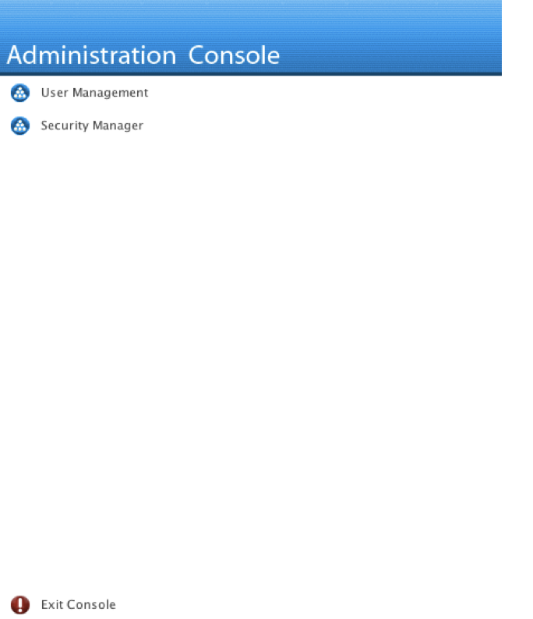
  - Create a Teacher Role and ensure that all of the LDAP teachers are assigned to the role
  - Create a Student Role and ensure that all of the LDAP students are assigned to the role
  - Create a Reporters Role and ensure that:
    - A local user (not the system administrator) has the role
    - All of the LDAP teachers are assigned to the role
- Assign the appropriate permissions at the correct levels to accomplish the following:
  - System Administrators should be able to:
    - CREATE, EDIT, DELETE, SEARCH all collections
    - CREATE, DELETE, DISCOVER, EDIT and VIEW all items in all collections
    - CREATE, DESIGN, EDIT, EXECUTE all reports
    - CREATE, EDIT all metadata schemas
  - Teachers should be able to:
    - SEARCH all collections
    - CREATE, DELETE, DISCOVER, EDIT and VIEW all items in all collections
  - Students should be able to:
    - DISCOVER, SEARCH and VIEW items in the Teaching and Learning Collection
  - The Reporters should be able to:
    - EXECUTE all reports
- Assign the appropriate permissions to show the correct navigation groups and links to the following:
  - All logged in users should be able to see the About navigation group and all links in the group
  - Teachers and Reporters should be able to see the Administer navigation group, and the Generate Reports navigation link
  - Teachers should be able to see the Create navigation group and all links in the group
  - All logged in users should be able to see the Home navigation group and all links in the group.
  - Teachers should be able to see the Search navigation group and the Basic Search navigation link
- Log in as a Student.
  - Can you perform a search? ____________________
  - Given your configuration, why can’t you search? ___________________
  - Test your hypothesis by fixing the reason. What did you do? ___________________________

- Login as a Teacher. Perform a basic search with no parameters. How many items do you find? ________________________

Collection
What follows are tasks related to the collections, dynamic access to collections, display summary modifications and expert scripting. Please complete these tasks with a user in the system administrator group unless otherwise specified.

Visibility Scripting (Contribution Wizard)
Using the “Teaching & Learning” collection, modify the ‘Generic schema’ (if need be) and contribution wizard to allow for the following scenario:
Teachers upload teaching and learning material as well as assessments. Currently there is a top level distinction for these materials, based on the node
‘/xml/item/lom/educational/learningResourceType’
and the contribution wizard control “Select the type of item to contribute”. The following assessment types are currently available for selection:
- Assessment (Formative)
- Assessment (Summative)
- Assessment Guide
You will need to replace these with a single ‘Assessment’ type. Whenever a user chooses this new ‘Assessment’ type, a new wizard control needs to be displayed, allowing the user to pick from a list of ‘Assessment’ types:
- Assessment (Formative)
- Assessment (Summative)
- Assessment Guide
- Past Exam Paper
This sub-selection needs to be written to the new schema node ‘learningResourceSubType’.
You will have to write a script to show/hide this control in the contribution wizard based on the user selection under ‘learningResourceType = Assessment’.
You will also need to modify the Item Summary Display Template to allow the ‘learningResourceSubType’ to be displayed together with the ‘learningResourceType’ as additional metadata nodes.
To test your implementation, please upload a document (under ‘Downloads’ in your Ubuntu VM distribution you will find some examples) to the ‘Teaching & Learning’ collection as an assessment and test that the wizard scripting works and that the item summary display templates shows this information correctly.

Expert Scripting (Save script)
Using the “Authors” collection, write an expert script that, on saving an item at contribution time:
Gets the values from the metadata nodes (you may find that the preceding /xml is not needed):
/xml/item/itembody/author/givenName
/xml/item/itembody/author/surname
- Concatenates the two values with a space separator
- Sets the concatenated value (author’s full name) into:
/xml/item/itembody/author/fullName
Modify the display template to display the value of:
/xml/item/itembody/author/fullName
Make sure you test the display and save script by contributing an item to this collection and then viewing the item summary display.

Search Display Summary
Using the ‘EQUELLA Documentation’ collection, modify the search display summary so that it also displays the user-entered information called ‘EQUELLA Version’ in the search results. HINT: You will need to find the target node in the contribution wizard.

EQUELLA Reporting
You are asked to write a report for EQUELLA that shows the following information:
A list of items with the following information for each of the EQUELLA items found. For the column headings of the report output, please use the following textual information, rather than what is returned by the query as column headers:
Item Name, Item UUID, Item Version, Item Status, Item Owner (Username), Item Owner (Email)
The following conditions must be added to the SQL query:
- The status of the item must be set to ‘Live’
- The version of the item must be version 1
- Only show items of the institution you are connected to
When creating the design of the report, you will need to use a Grid layout as well as a Table layout and make sure you have a Header as well as a Footer section. The Header sections needs to read:
EQUELLA EQ302 Exercise Report
The footer section should have a horizontal line (HTML <hr>) and the following text underneath.
EQUELLA Footer
Once you have written the report, review the report and show the instructor that the report has finished and what the output is. Once confirmed the result, please log in to EQUELLA with a valid reporting user, which you have created in the previous User Management and Security question, and upload the report into EQUELLA (this needs to be done in the Administration Console). Your user will have to have the permissions to create reports in EQUELLA.

Institution Export
Once you have finalized your exercises, please export your institution and copy it onto an external USB drive for the instructor or upload it into EQUELLA as an item and share it with the instructor.

